

**TimeWise**

**Software Requirements and Specification**

**Supervised By**

Mridha Md Nafis Fuad

Lecturer, IIT, DU

**Submitted By**

Abdus Salam Islam Badhon (BSSE 1401)

Md. Nahidur Rahman Nahid (BSSE 1429)

**__________________**

**Supervisor’s Signature**

**Table of Contents**

Introduction......................................................................................................................3

Inception Report………………….....................................................................................4

Elicitation Report…………………….................................................................................5

Normal Requirements......................................................................................................5

Expected Requirements.................................................................................................. 6

Exciting Requirement:......................................................................................................6

User Story………………………………………………………………………………………10

Scenario Based Modeling ………...................................................................................13

Use Case Diagram :Timewise........................................................................................10

Level 0............................................................................................................................10

Level 1............................................................................................................................11

Level 1.1.........................................................................................................................12

Level 1.2.........................................................................................................................13

Level 1.3.........................................................................................................................14

Level 1.4.........................................................................................................................15

Level 1.5.........................................................................................................................16

Level 1.6.........................................................................................................................16

Level 1.7.........................................................................................................................17

Level 1.8.........................................................................................................................18

Activity Diagram : TimeWise...…………………………………………………….…………45

Level 1..………………………………………………………………………………………..19

Level 1.1………………………………………………………………………………………..20

Level 1.2………………………………………………………………………………………..21

Level 1.3………………………………………………………………………………………..22

Level 1.4………………………………………………………………………………………..23

Level 1.5..………………………………………………………………………………………23

Swimlane Diagram: TimeWise….……………………………………………….…………...24

Data Based Modelling....................................................................................................25

Collections Schema………:............................................................................................33

ER Diagram……...………:..............................................................................................40

Class Based Modeling:TimeWise:.................................................................................40

Class Card……...………:................................................................................................51

CRC Diagram...………:...................................................................................................63

Behavioral Modeling...………:........................................................................................63

State Transition Diagram …:...........................................................................................67

Sequence Diagram …:...................................................................................................71

Data flow diagram(DFD) …:...........................................................................................73

Introduction:

Welcome to the Software Requirements Specification(SRS) for TimeWise, a productivity management tool through task management. This document highlights the functionalities and requirements of the tool. This document will firstly begin by addressing the inception and elicitation report of TimeWise.Then it will address different modelings like scenario based modelings, database modeling, class based modeling , behavioral modeling . Then finally this document will address the data flow diagram.

Purpose:

The main purpose of TimeWise is to help users manage their tasks in a proper way to become more productive. In this era of social media distractions, a tool that organizes daily tasks with proper timings and deadlines along with time to time reminders can lessen procrastination and can make daily activities more manageable.

Intended Audience:

All the reports,modeling and diagrams used in this SRS can give a proper and clear idea about our tool which can be helpful for software developers,stakeholders,system architects, project managers, quality assurance professionals,end users as well as someone who is interested about the functioning of TimeWise.

Conclusion:

In conclusion we the creators of the tool Abdus Salam Islam Badhon ([bsse1401@iit.du.ac.bd](mailto:bsse1401@iit.du.ac.bd)) and Md Nahidur Rahman Nahid ([bsse1429@iit.du.ac.bd](mailto:bsse1429@iit.du.ac.bd)) believe that this SRS will help the intended audience to get the clear understanding of our tool. And we are also grateful to our supervisor Mridha Md Nafis Fuad([fuad@iit.du.ac.bd](mailto:fuad@iit.du.ac.bd)) sir for guiding us regarding the project.

1. Inception Report:

1.1 Project Overview and Objectives

TimeWise is a productivity tool that helps users to manage their daily activities.. Our tool now totally free to use so this document will not address any payment related specifications.TimeWise will have different features like listing daily activities in a to-do format, tracking progress and performance, getting time to time reminders and notifications, seeing relevant statistics of the participations,getting personalized feedback and tips and managing productivity in a collaborative and competitive environment.

1.2 Stakeholders

TimeWise is a tool which can be useful for anyone trying to organize their task and time. It is not created based on a particular group of people like students, working professionals,employees,managers and so on. It can be useful for many categories of people. So in the rest of the documents we will address all of these categories of people simply as users.So the stakeholders are the followings:

1.Users

1.1 Students

1.2 Teachers

1.3 Working Professionals

1.4 Employees

1.5 Managers

1.6 Others

1.3 Methodology and Requirements Collection Plan

To collect requirements we will talk to the stakeholders personally and will collect their personal experience and recommendations regarding managing their daily activities. We may also collect information from a vast amount of stakeholders by some online means. We will also refer to research papers, reports,relevant books for collecting information about productivity related contents. We will take notes about our findings and will refer to these in developing and planning the system.

1.4 Assumptions and Risk

We will assume that the user will behave in a fair way like giving the actual input. If they dont the outcomes and results that our system will show will be biased and will be not beneficial for the users. Our current system will not address any dedicated efforts to stop cheating of the user. Maybe in the later versions we may consider these issues. So we expect the user to be fair for their own benefits.

1.5. Timeline and Strategy

In the beginning phase we will be collecting requirements and relevant information and make proper documentation of the findings. Then the UI/UX planning and actual development will be done. Followed by testing and bug fixing. Finally we will deploy the tools and will provide user documentation for better user experience. We will follow the iterative process model to develop the actual system. Where after each iteration we will perform the required changes. And we may develop independent part parallel so that integration of different modules becomes easy.

2. Elicitation Report:

2.1 Quality Function Deployment(QFD)

The Quality Function Deployment(QFD) is a structured approach to define user needs or requirements and translating them into specific plans to produce products to meet those needs.Based on our observations after interaction and research on the subject we summarized the following requirements that will be implemented on our tool.

2.1.1 Normal Requirements

**1. Users Account management:** The user will be able to create an account by providing some personal information like name,email address and so on.Our system will maintain a profile for each user.

**2. Task & Goal Management:** The user will maintain some tasks which they will perform from time to time. The task will contain a task goal which will help the user cluster the taks with a broader sense.

**3. Progress Tracking:** Based on users tasks, the user will be able to track his progress of the current assigned tasks.Our system will provide a daily progress report which will contain the deadline and current progress of all the unfinished tasks.

**4. Performance Tracking:** Users can evaluate his performance based on the performance report that they will receive once every week and this performance report will containing user account,tasks and session related statistics over the previous week.

2.1.2 Expected Requirements

**1. Reminders & Notifications:**Users will be notified from time to time based on his setted tasks and activities.

**2. Showing Stats:** Users will be able to see relevant statistics about his performance and participation.

2.1.3 Exciting Requirements

**1. Deep work tracking :** Users can track their hours spent on sessions, no of tasks operated within these sessions and also an average productive score over the different hours of the day in the form of productivity meter.

**2. Collaborative and competitive environment:** Users will be able to share their tasks and plans with others. They can also create a team and share tasks with team members.Users can also send messages and can see other users' accounts .

**3. User story:**

#### **3.1 User Registration and Profile Management**

User wants to create an account and manage his profile, so that he can securely use TimeWise and access personalized features.

* Scenario:
  1. The user accesses the registration page.
  2. The user enters their name, email, and other required information.
  3. The system validates the input and creates an account.
  4. The user logs in to access their personalized dashboard.
  5. The user updates their profile with additional preferences, such as productivity goals.

**3.2 Task Management**

User wants to maintain a to-do list so that he can organize his tasks and track their completion.

Scenario:

* 1. The user logs into the TimeWise dashboard.
  2. The user creates a goal and adds tasks to that goal or creates an individual task by specifying the task name, description, priority level, and deadline.
  3. The system displays a list of tasks with filters for priority, deadlines, and categories.
  4. The user marks tasks as completed once finished.

#### **3.3 Progress and Performance Tracking**

User wants to track his progress and evaluate his performance,so that he can see how effectively he is achieving his goals.

* Scenario:
  1. The user sets specific goals within the app.
  2. The system tracks the completion of tasks relative to the user’s goals.
  3. The user views a dashboard summarizing progress, including completed tasks, pending tasks, and overdue tasks.
  4. The system generates performance insights, such as percentage completion and streak achievements.

#### 

#### 

#### 

#### 

#### **3.4 Reminders and Notifications**

As a user, I want to receive reminders and notifications for my tasks,so that I can stay on track and meet deadlines.

* Scenario:
  1. The user sets a deadline for specific tasks during the task creation process.
  2. The system sends an automatic notification or email shortly before the task deadline, serving as a final alert to encourage timely completion.
  3. The system reminds the user about overdue tasks.
  4. The user can view his previous notifications from the notifications panel.

#### 

#### **3.5 Statistics and Insights**

As a user,I want to see statistics about my productivity,so that I can analyze and improve my daily performance.

* Scenario:
  1. The system generates visualizations such as bar graphs and pie charts showing the percentage of tasks completed.
  2. The user can filter statistics by day, week, or month.
  3. Insights highlight the user’s most productive times and least productive tasks.

#### **3.6 Deep Work Tracking**

As a user,I want to monitor my deep work sessions,so that I can identify the time periods when I am most productive.

* Scenario:
  1. The user activates the “Deep Work” mode during focus sessions.
  2. The system tracks the time spent on deep work and distractions.
  3. The user views a report of focus intervals, identifying peak productivity hours.

#### **3.7 Collaborative and Competitive Environment**

As a user,I want to share my goals and performance with others,so that I can collaborate and compete to stay motivated.

* Scenario:
  1. The user shares specific goals or task lists with their group.
  2. The system displays a leaderboard ranking users based on scores that they have achieved through their performance.
  3. The user receives feedback and encouragement from peers.

3. Scenario Based Modeling

The success of a computer-based system depends highly on the user's satisfaction. So if we can create different scenarios of users interacting with our system we can target these interaction scenarios and make them useful to give an overall good experience. Scenario based modeling highlights these users' interactions. This modeling uses different diagrams like use case diagram, activity diagram and swimlane diagram.These diagrams along with proper description and explanation are given below:

3.1 Use Case Diagram: Timewise

A use case is a detailed description of how a user interacts with a system to accomplish a specific goal. It focuses on the user's perspective, outlining the steps involved. Primary actors are the main users directly interacting with the system and positioned at the left side , while secondary actors are external entities that provide or receive information but aren't directly using the system positioned at the right side.In the middle the main modules with which the user interacts are placed.Actors doesnt need to be physical person it can be intangible entity also like mail,third party software and so on.To show the interaction between modules and actors a line is drawn between actors and modules name. Now the use case diagram of TimeWise will be shown below:

3.1.1 Level 0

**Name:** TimeWise(A time and productivity management system)

**PrimaryActor:** User(Student,Teacher,WorkingPrefessional,Employee,Managers,Others)

**Secondary Actor:** Central Database

[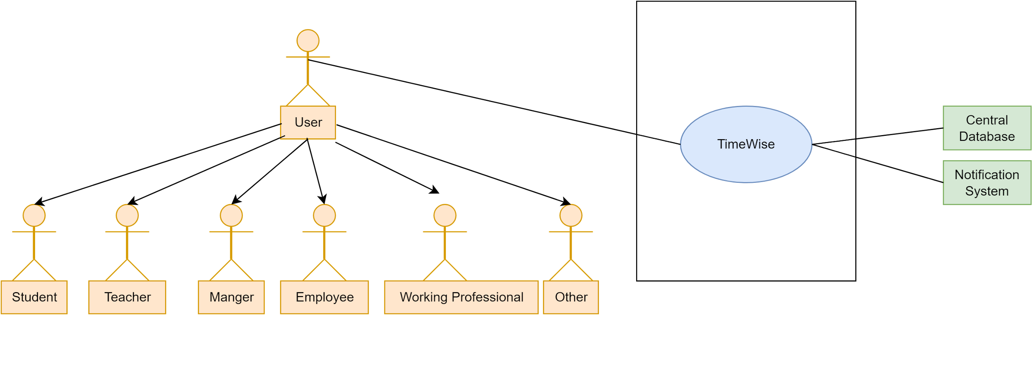](https://app.diagrams.net/?page-id=lnonrUPNMiSJG-7Qp96J&scale=auto#G1OXqhkd54wwl-46aviZ00bA-DMpYdVPli)

Figure 1: TimeWise(A time and productivity management system)

3.1.2 Level 1

**Name:** TimeWise System Details

**PrimaryActor:** User(Student,Teacher,WorkingPrefessional,Employee,Managers,Others)

**Secondary Actor:** Central Database

[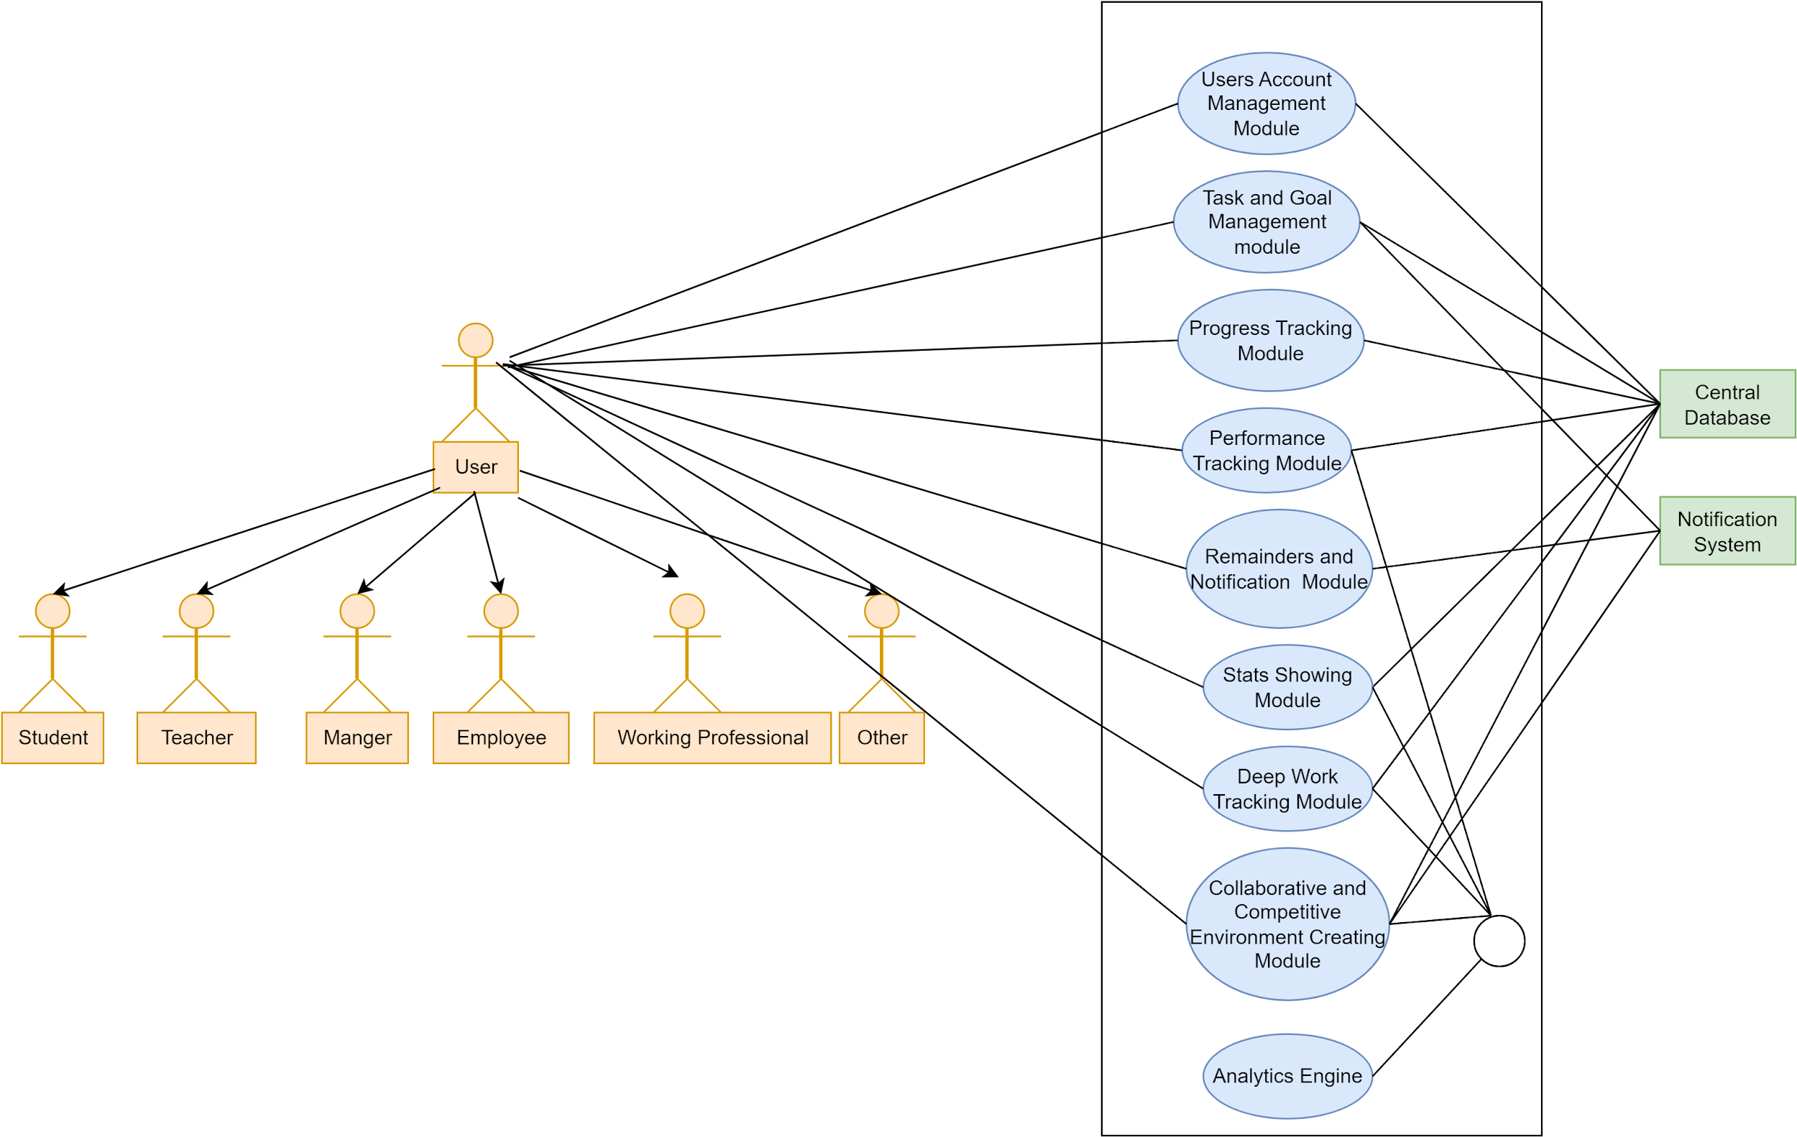](https://app.diagrams.net/?page-id=5Ep43n3G_8iIJSV3E2aV&scale=auto#G1ppG80JHn_XJio1zb_8FSoVjxcr_4WeyS)

Figure 2: TimeWise System Details

**Descriptions:**

**Users Account Management Module:** Manage users account related activities like sign in ,sign up,collecting user credentials and maintaining a user profile and dashboard.

**Task Management Module:** Manages goal and task information and their corresponding deadlines. This module will contain all the functionalities regarding manipulating and updating the to do list.

**Progress Tracking Module:** Shows the progress of ongoing tasks and relevant information to complete the task.

**Performance Tracking Module:** Shows how the user performed over the period of time on different completed tasks and activities.

**Reminders and Notification Module:** Sends time to time reminders and notifications.

**Stats Showing Module:** Shows relevant statistics regarding the performance and participation of the user.

**Deep Work Tracking Module:** Shows how productive or efficient the users are over the different time spans.

**Collaborative and Competitive Environment Creating Module:** Creates a platform where users can collaborate with each other and become more productive by healthy competition.

The user will interact with all the modules as they are consumers of the whole system. The mail system will be used for sending notifications and reminders. The database will be a key part for providing and storing data to different modules. The admin will take part in managing users accounts.

3.1.2.1 Level 1.1

**Name:** Users Account Management Module

**PrimaryActor:** User(Student,Teacher,WorkingPrefessional,Employee,Managers,Others)

**Secondary Actor:** Central Database

[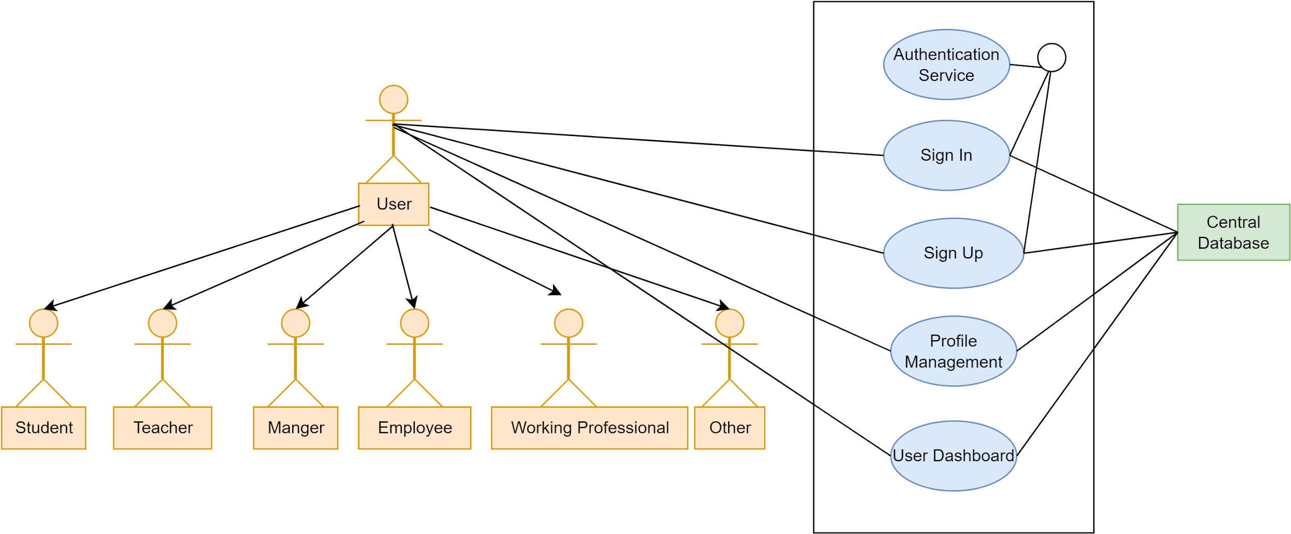](https://app.diagrams.net/?page-id=IOBFKqrxkaWz8YnhxEr4&scale=auto#G12Biwgp09lsqEmQ0w6_07t-LmRrbIcaiM)

Figure 3: User Account Management Module

**Description:**

Users will be able to sign in and sign up by providing necessary credentials. They can manage their account by deleting or deactivating their account. Admins will also be able to govern the account of the user like removing unlawful users from the system. Users will also be able to modify their profile details and can see all of their information in the user dashboard.

3.1.2.2 Level 1.2

**Name:** Task & Goal Management Module

**PrimaryActor:** User(Student,Teacher,WorkingPrefessional,Employee,Managers,Others)

**Secondary Actor:**Central Database

[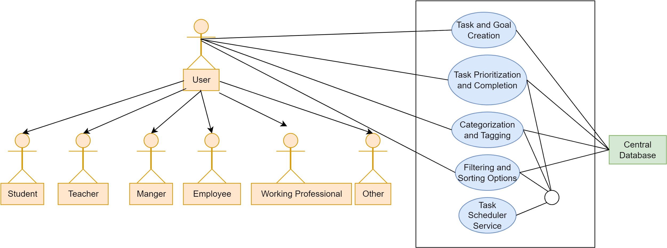](https://app.diagrams.net/?page-id=7bbSqT4xshHzTUvxiv2a&scale=auto#G1e71-aSUyi3OHE7HaaMWfx4uTWoyXS94q)

Figure 4:Task & Goal Management Module

**Description:**

Users will be able to manage tasks like adding,removing,updating tasks details. They can set and modify the details about task prioritization and completion. They can categorize,filter,sort and tags different tasks.

3.1.2.3 Level 1.3

**Name:** Progress Tracking Module

**PrimaryActor:** User(Student,Teacher,WorkingPrefessional,Employee,Managers,Others)

**Secondary Actor:** Central Database

[](https://app.diagrams.net/?page-id=7bbSqT4xshHzTUvxiv2a&scale=auto#G1e71-aSUyi3OHE7HaaMWfx4uTWoyXS94q)

Figure 5:Progress Tracking Module

**Description:**

Users can monitor progress status like seeing deadlines and completion status which can help them to focus on the tasks that are close to the deadline but not yet finished. They see the progress reports to work on the ongoing task.

3.1.2.4 Level 1.4

**Name:** Performance Tracking Module

**PrimaryActor:** User(Student,Teacher,WorkingPrefessional,Employee,Managers,Others)

**Secondary Actor:** Central Database

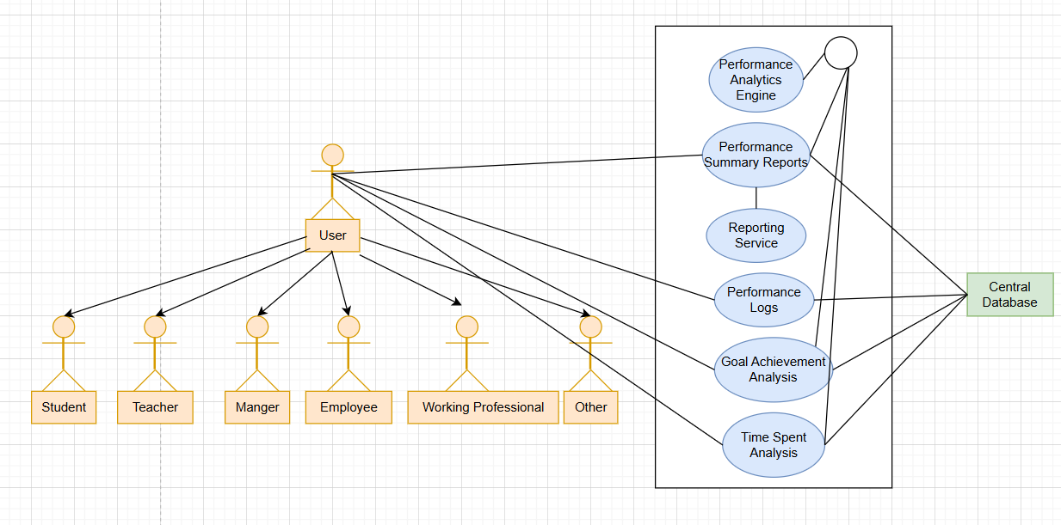

Figure 6:Performance Tracking Module

**Description:**

Users can see the performance reports which may be helpful to evaluate his performance. They can see performance logs on different time intervals. They can also see goal achievement as well as time spent analysis.

3.1.2.5 Level 1.5

**Name:** Reminders and Notification Module

**PrimaryActor:** User(Student,Teacher,WorkingPrefessional,Employee,Managers,Others)

**Secondary Actor:** Central Database,Email Service

[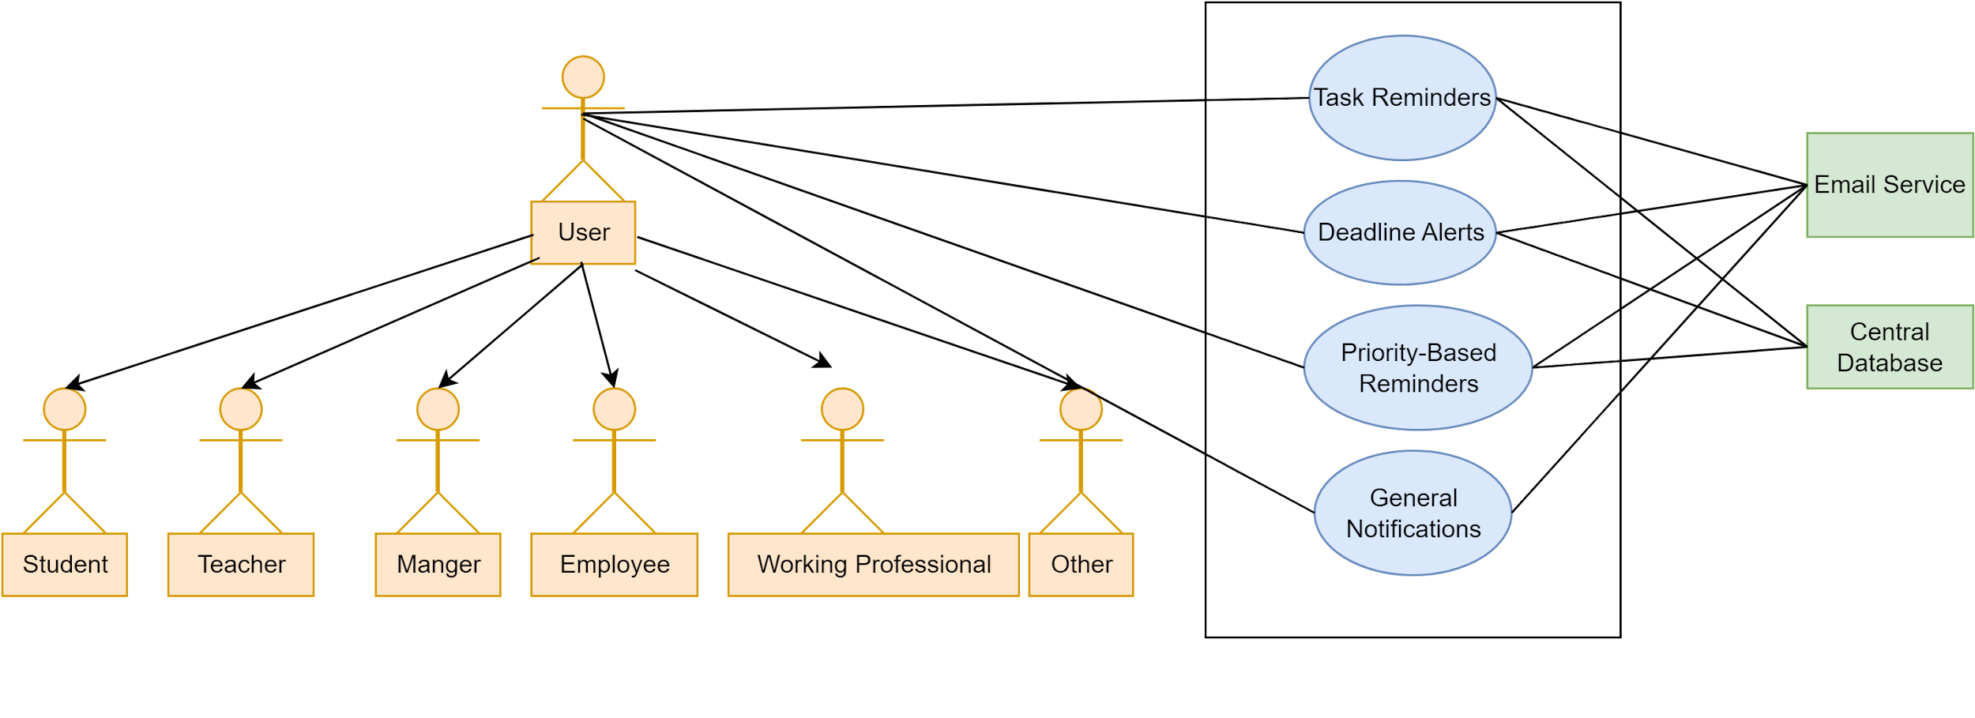](https://app.diagrams.net/?page-id=txsZjO7vKs0XT66AJvK2&scale=auto#G19osDktNTyjxZllwFMAZWI1FuzvMWUKe4)

Figure 7: Reminders and Notification Module

**Description:**

Users will get time to time alerts to deadlines and unfinished tasks. They will also get general notification regarding the service. Based on priority of tasks they will also get notification.

3.1.2.6 Level 1.6

**Name:**  Stats Showing Module

**PrimaryActor:** User(Student,Teacher,WorkingPrefessional,Employee,Managers,Others)

**Secondary Actor:** Central Database

[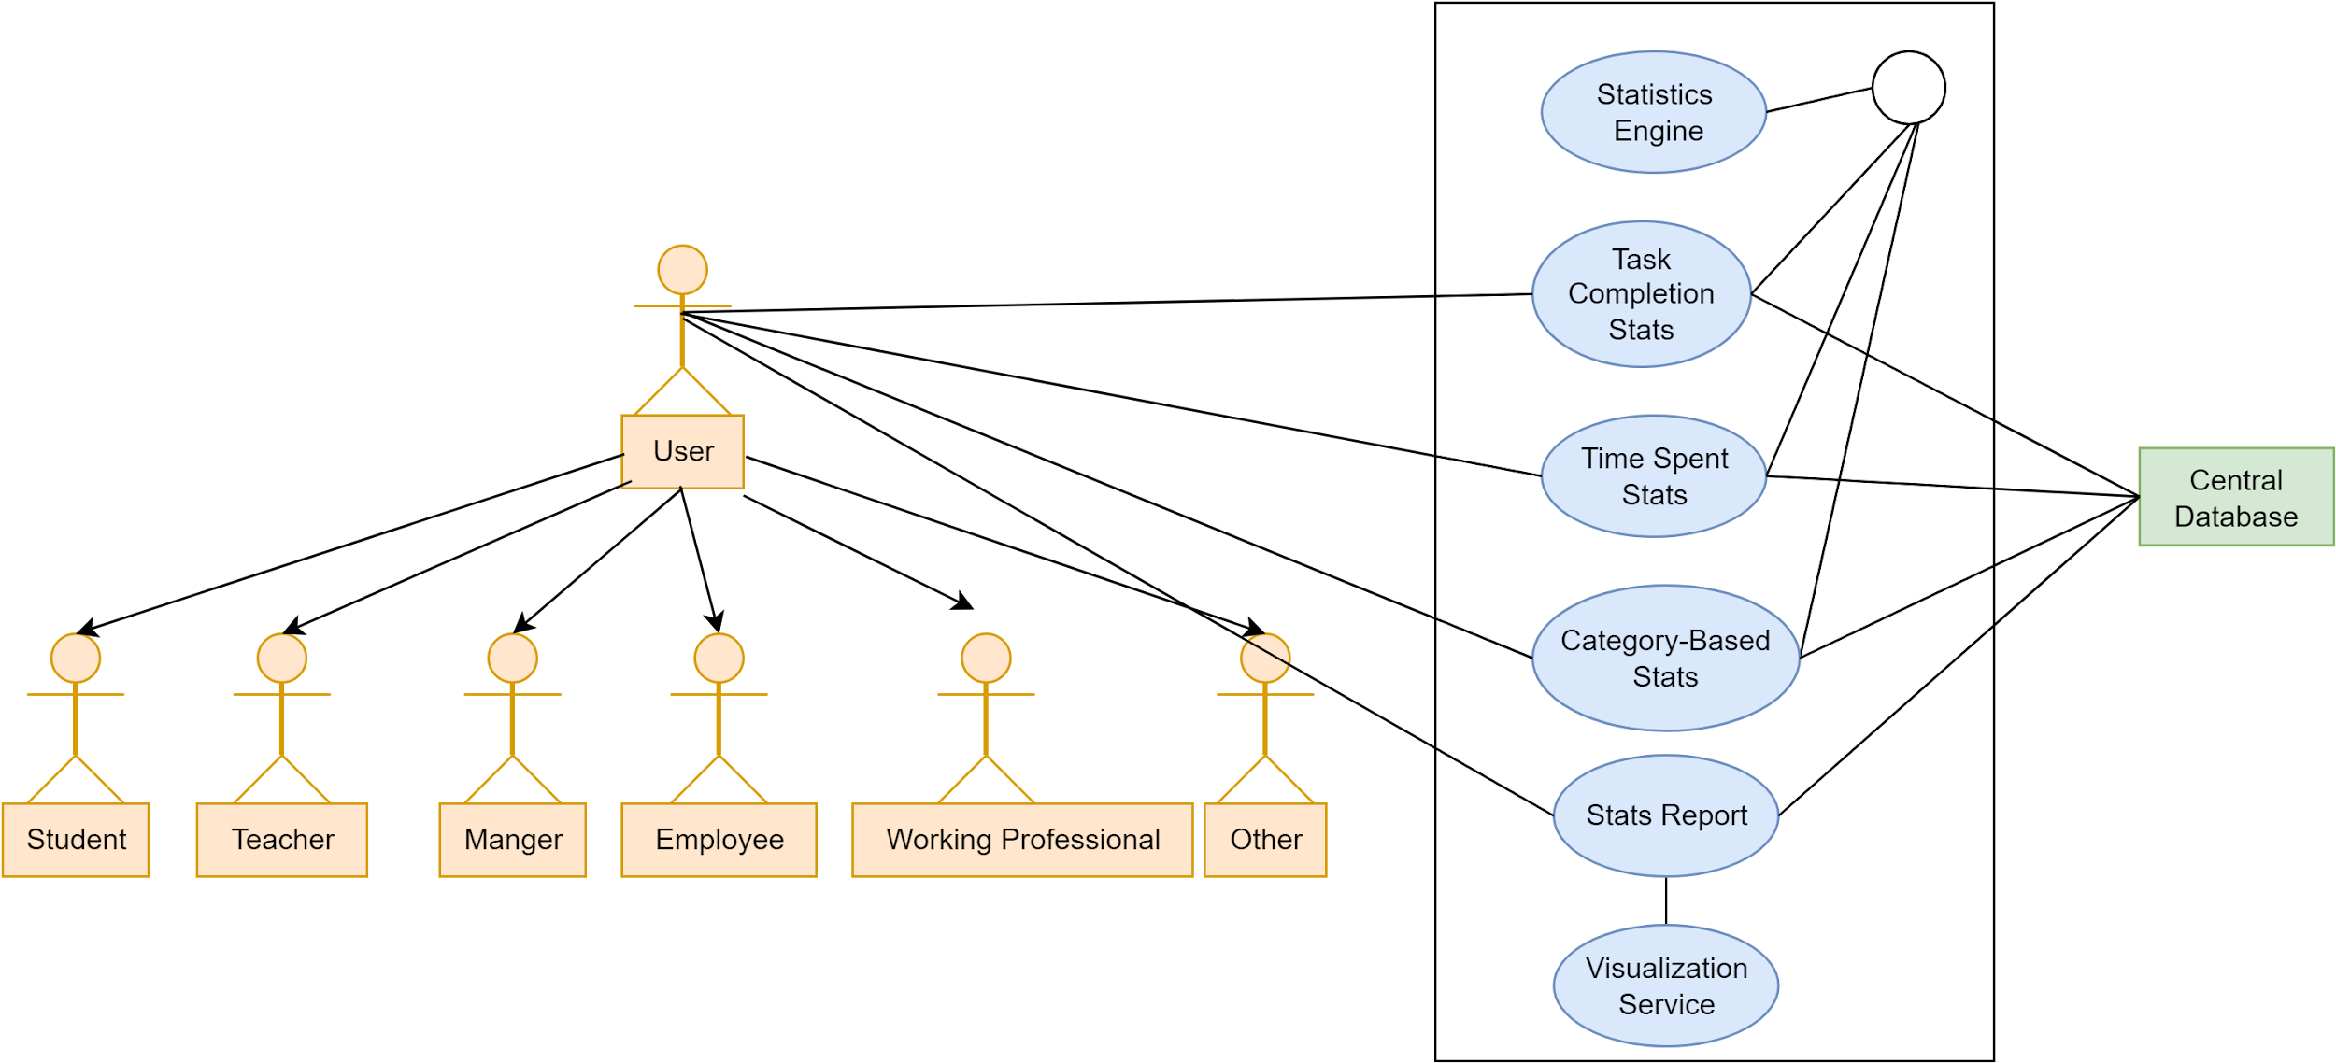](https://app.diagrams.net/?page-id=vaSSFvOXgG2yqRM5z1OH&scale=auto#G1mPFCE7wSViQOHLI0ChTtA1Jl45ks3jIS)

Figure 8:Stats Showing Module

**Description:**

The statistics engine with the help of a central database will visualize the user performance with the help of relevant statistics.

3.1.2.7 Level 1.7

**Name:**  Deep Work Tracking Module

**PrimaryActor:** User(Student,Teacher,WorkingPrefessional,Employee,Managers,Others)

**Secondary Actor:** Central Database

[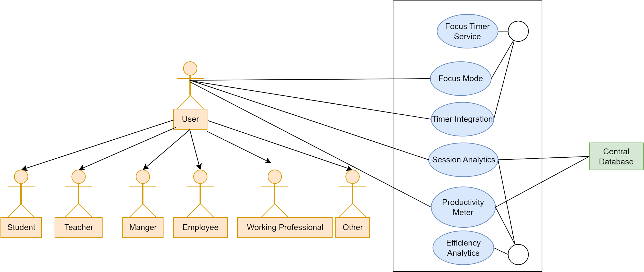](https://app.diagrams.net/?page-id=gi5pgJB8UzCgduBGHC_Y&scale=auto#G1Pxhi9rpScaylszASBdNGYxh-K-SoJM4E)

Figure 9: Deep Work Tracking Module

3.1.2.8 Level 1.8

**Name:**  Collaborative and Competitive Environment Creating Module

**PrimaryActor:** User(Student,Teacher,WorkingPrefessional,Employee,Managers,Others)

**Secondary Actor:** Central Database

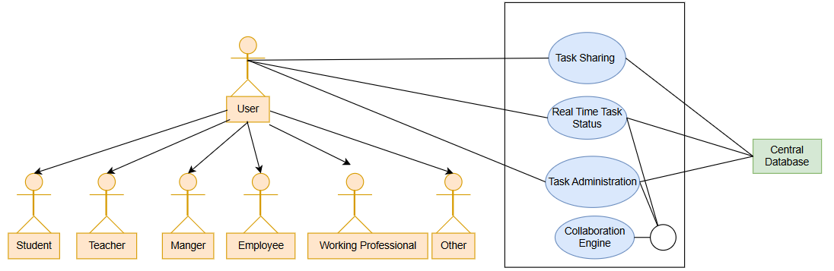

Figure 10: Collaborative and Competitive Environment Creating Module

Activity Diagram: TimeWise

Level 1:

[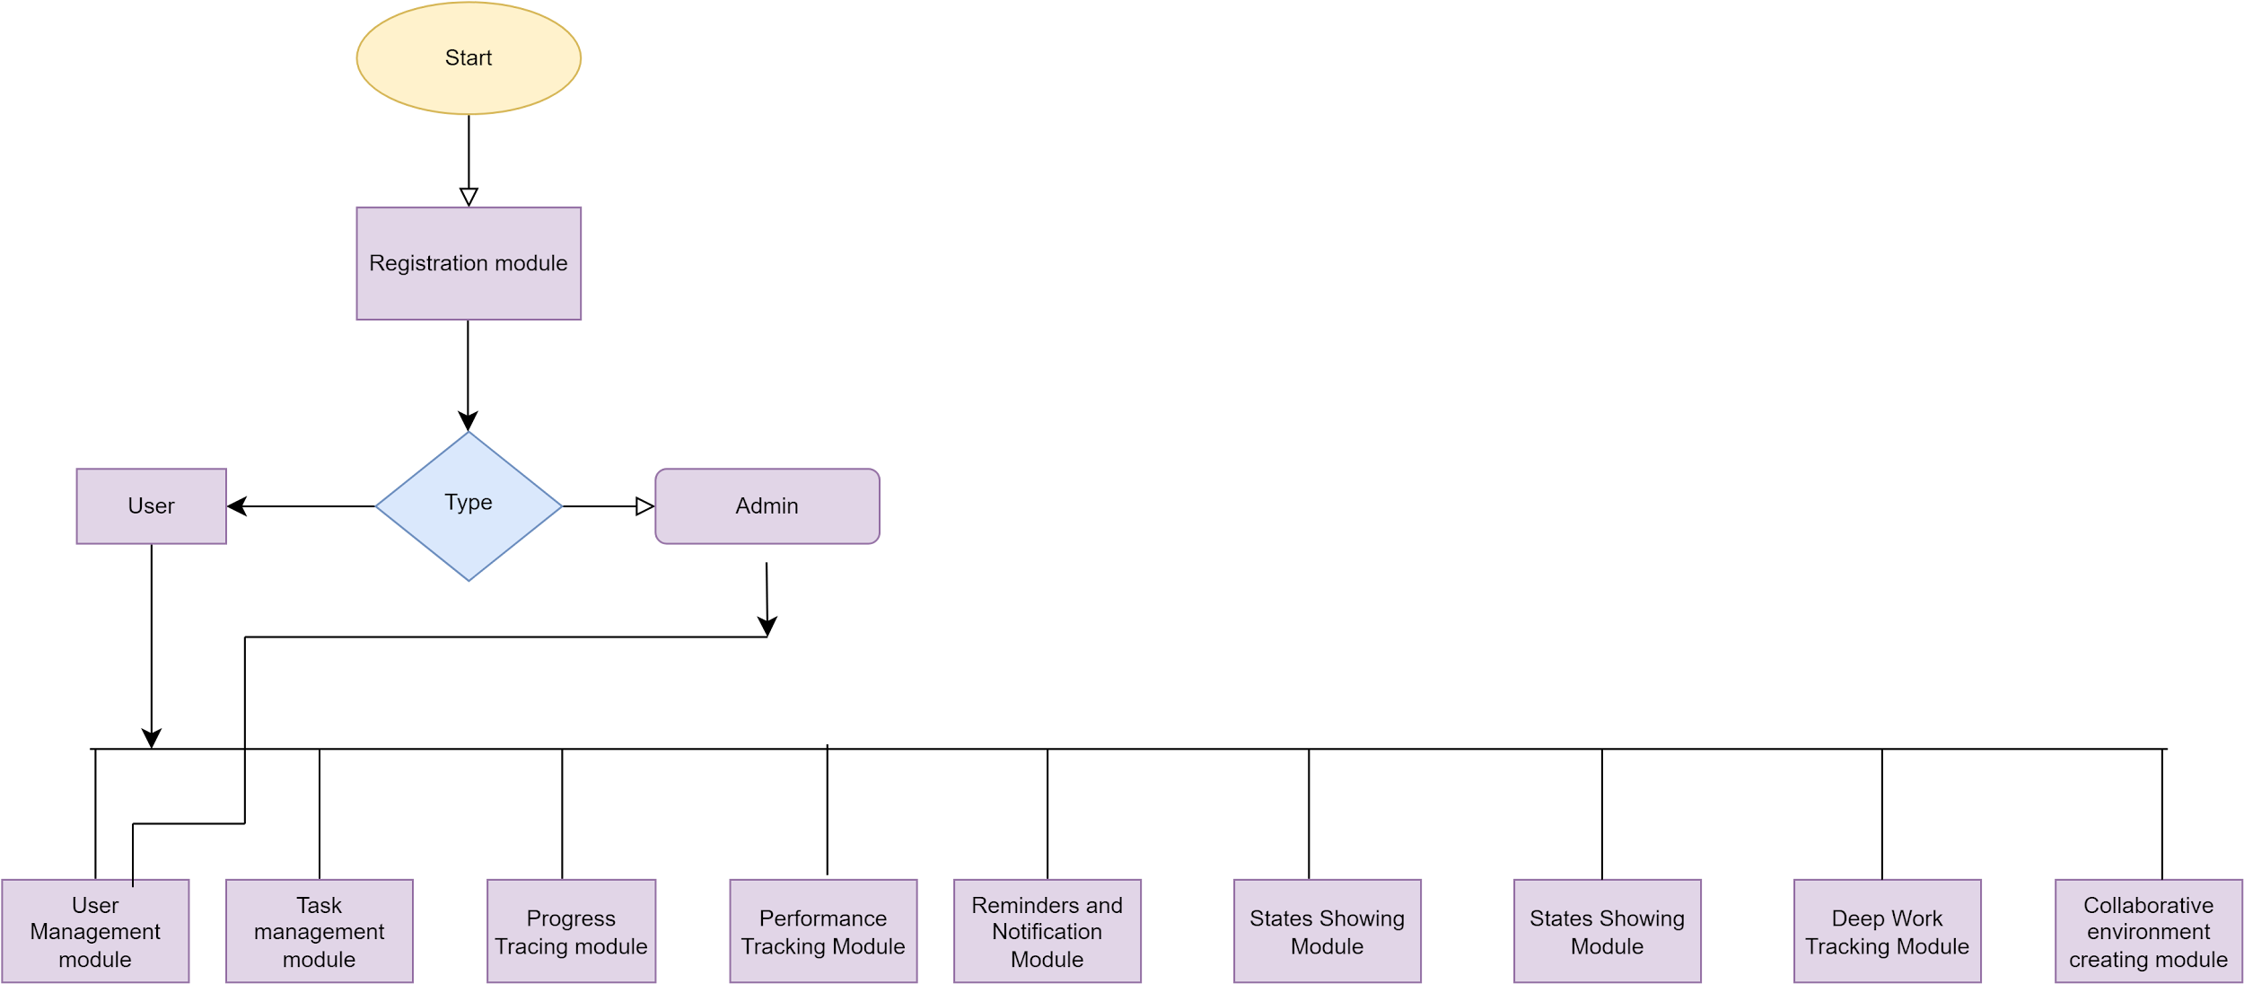](https://app.diagrams.net/?page-id=C5RBs43oDa-KdzZeNtuy&scale=auto#G1Q7URyTdA7WsxEc28v2MgB-yHQEikPTjl)

Level 1.1:

[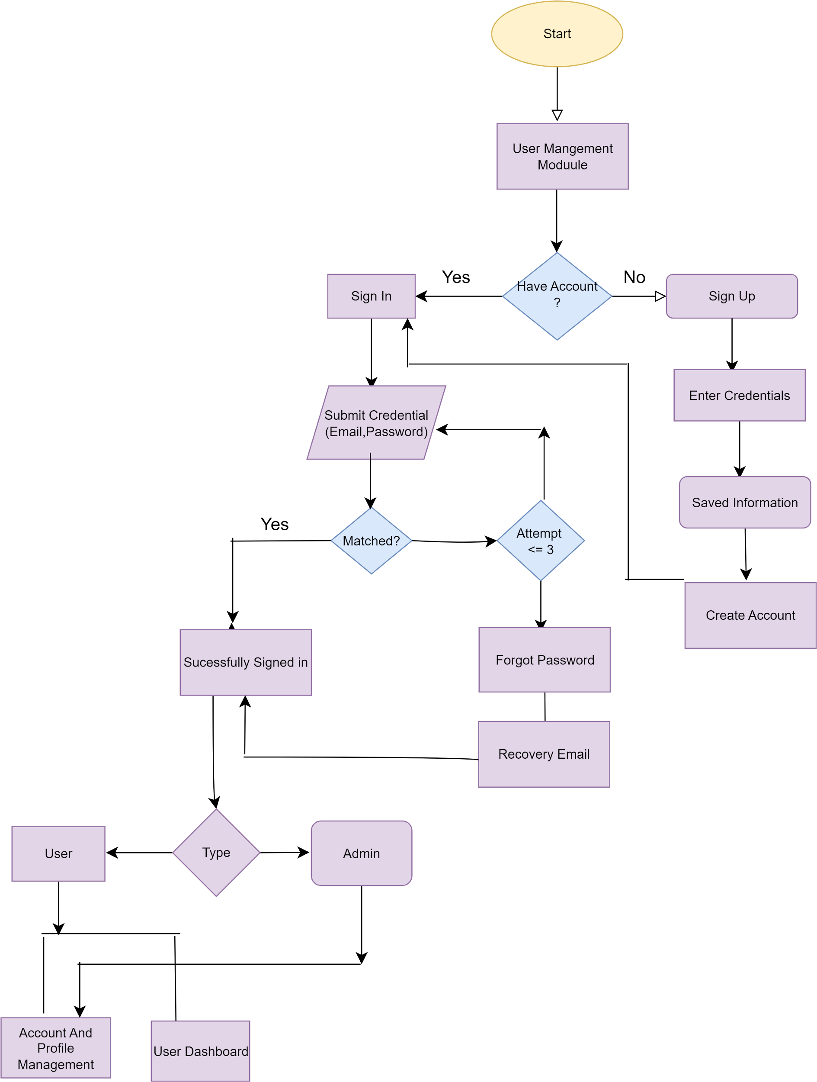](https://app.diagrams.net/?page-id=plBB_H1oWAMK_TOYRe7u&scale=auto#G1lv3HI0zyKhMt7N8EA63vcDDmLKpkuLMY)

Level 1.2:

[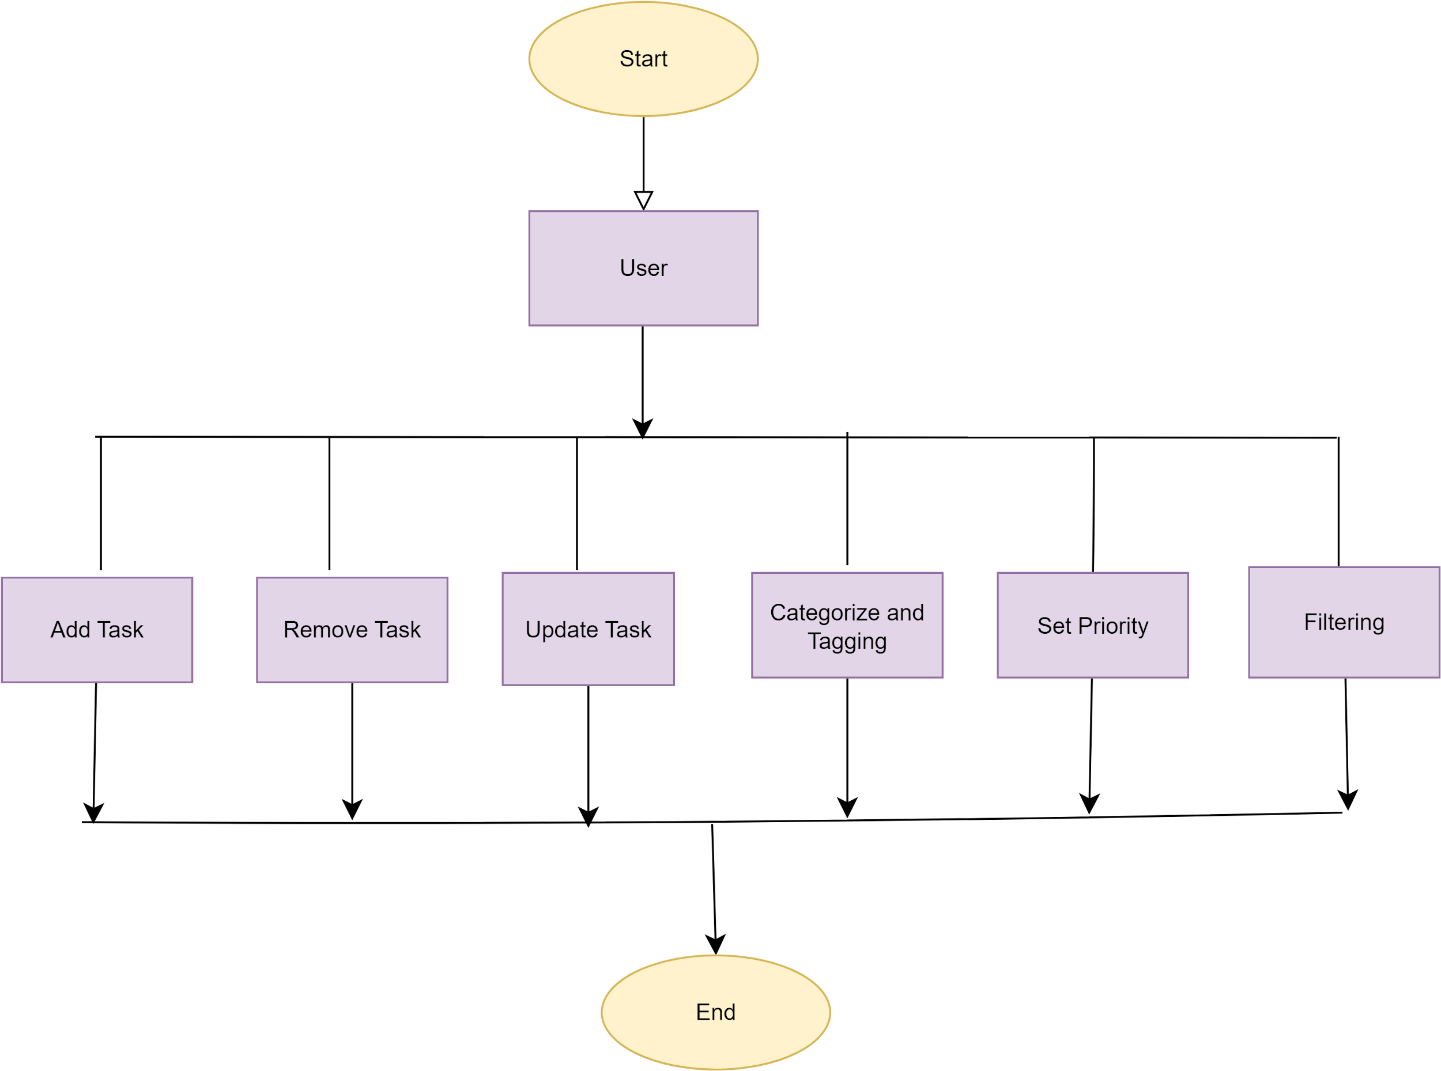](https://app.diagrams.net/?page-id=3WQtSSavZ7YvSEI_SyxG&scale=auto#G17mVKIISfz6WQIvj2HNCvrmm2dumOCG34)

Level 1.3:

[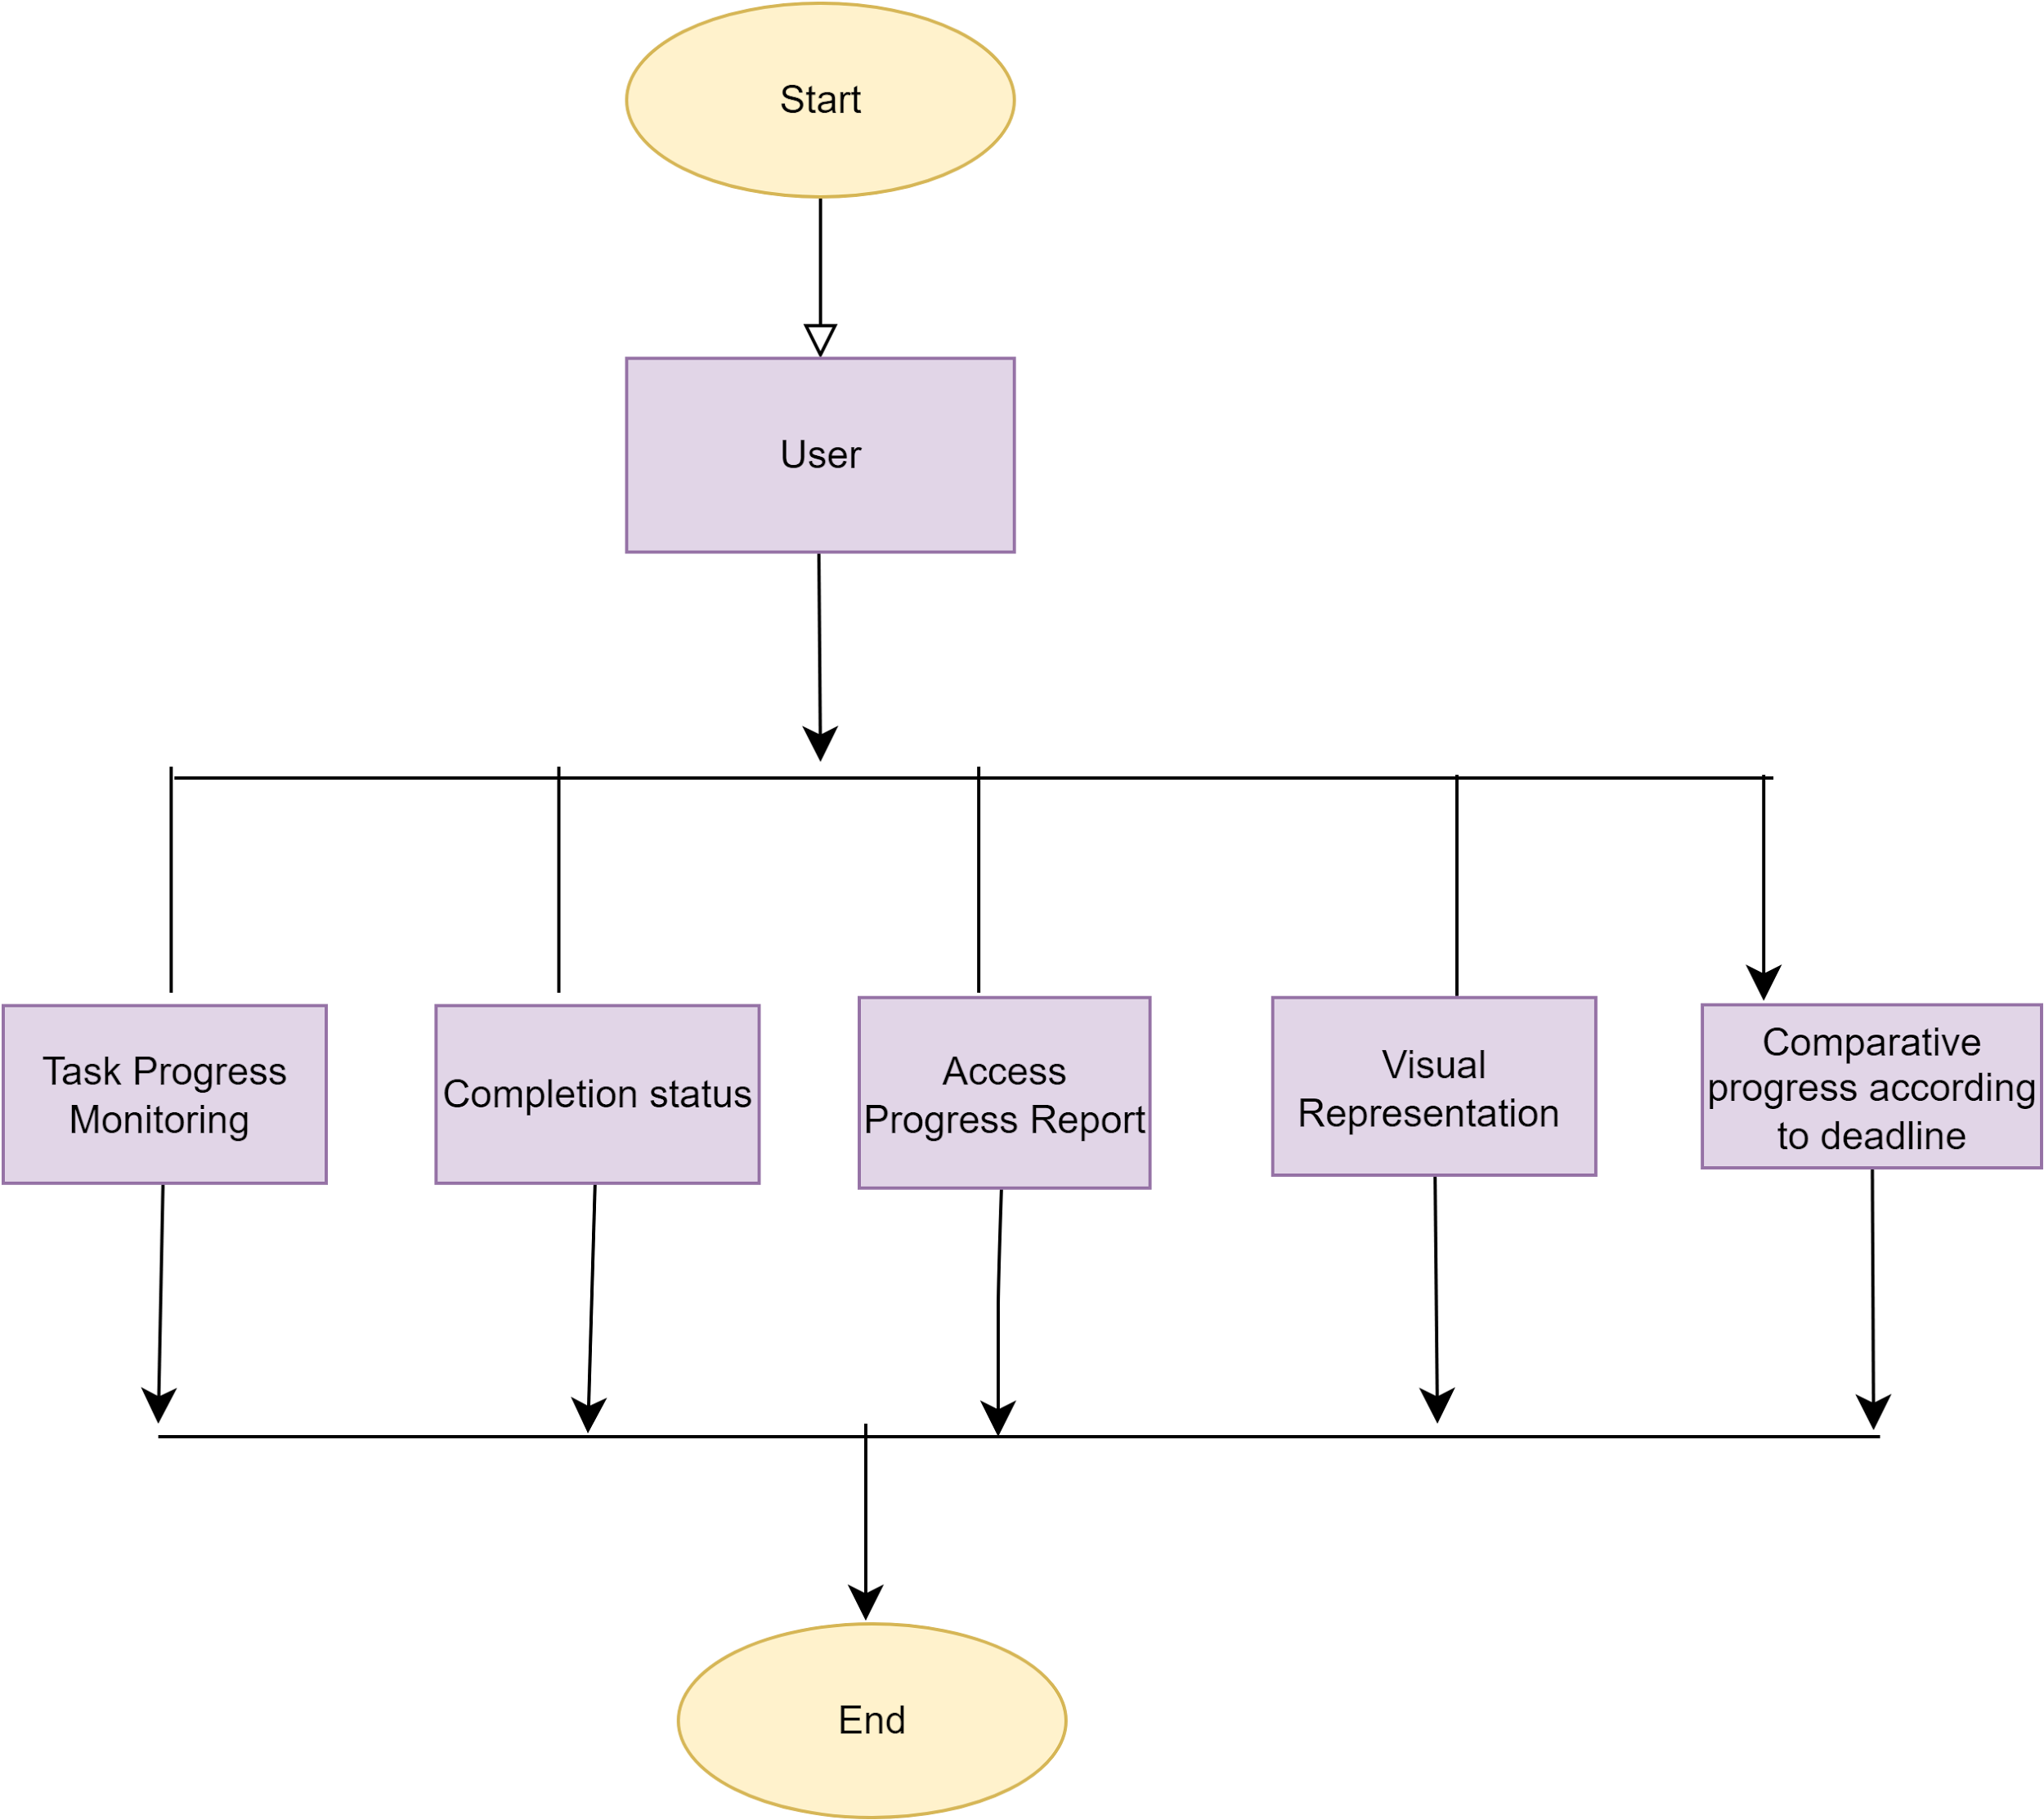](https://app.diagrams.net/?page-id=TEoQuVtJTDzYy-5z5AF5&scale=auto#G1MH6Zt-_P5wxDiytMefulDwCBvms_XYtd)

Level 1.4:

[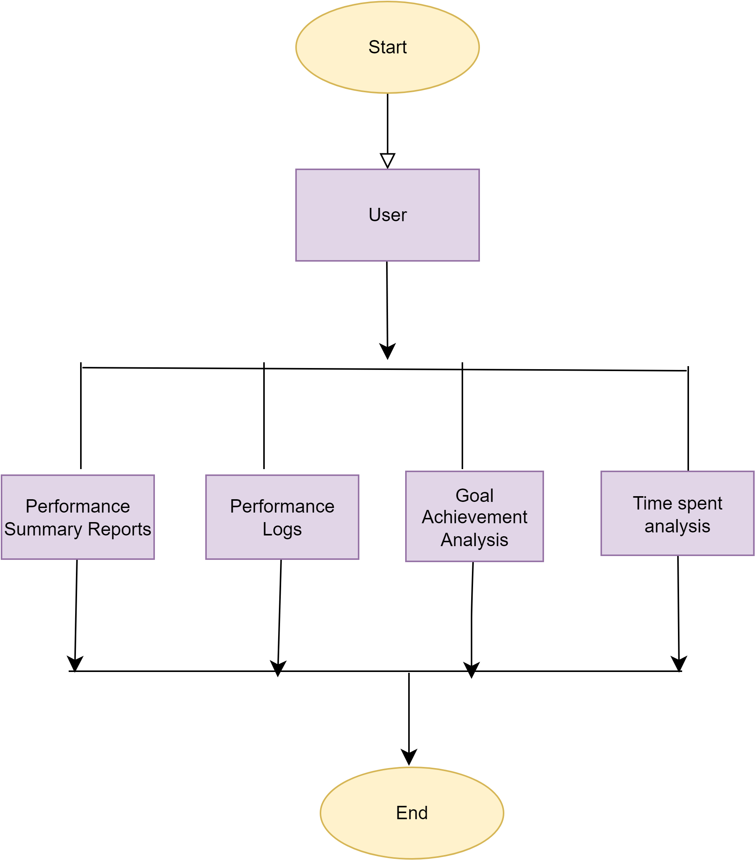](https://app.diagrams.net/?page-id=s_gNBslOq68JI9aONitm&scale=auto#G1EN-Sp31IOk7bmMJdM5eQ9smet6B9HSzX)

Level 1.5:

[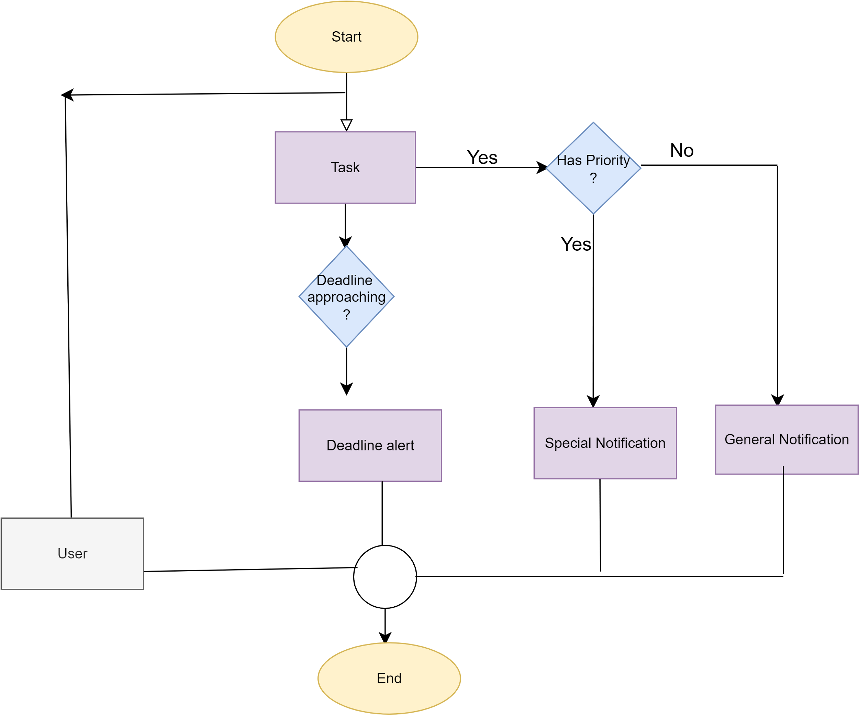](https://app.diagrams.net/?page-id=vgkR9bSOBxmjntfY41XF&scale=auto#G1-wuUR6OKg7Qt6-t-3kjHuNasgS6XAs4m)

3. Swimlane Diagram: TimeWise

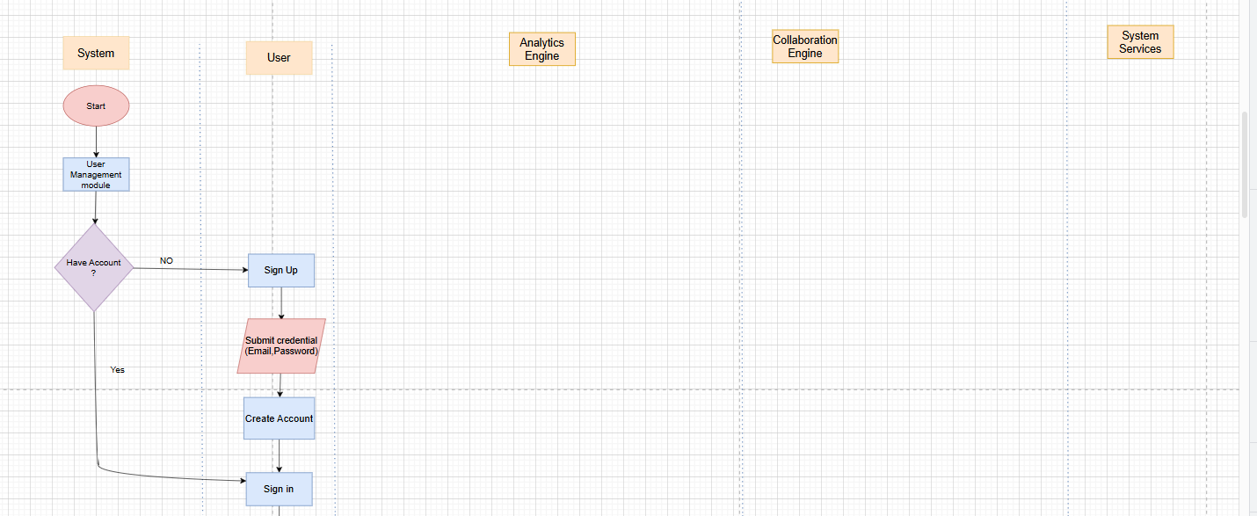

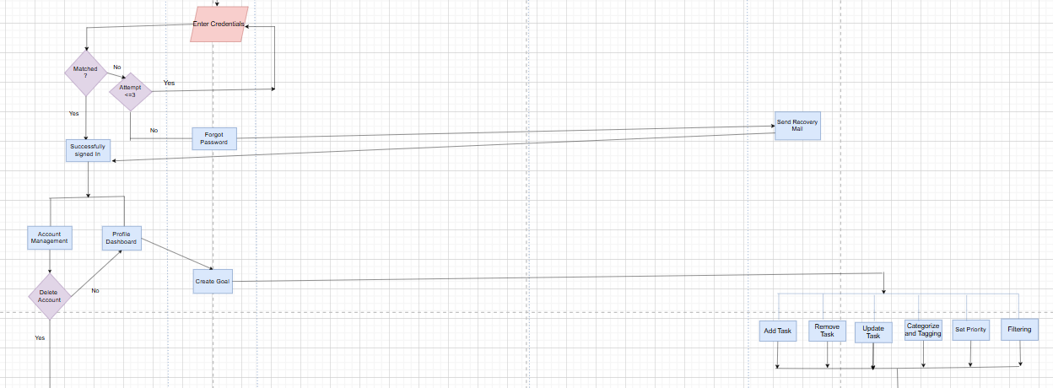

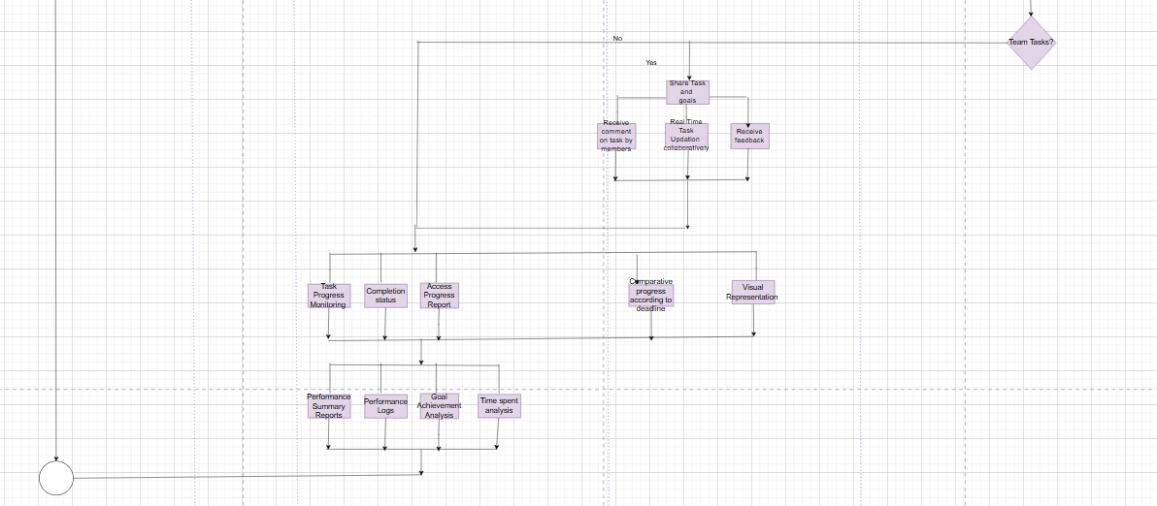

4. Database Modeling

4.1 What is Database Modeling?

Database modeling is the process of designing a detailed data structure that defines how information will be stored, organized, and accessed within a database. It involves creating conceptual, logical, and physical models that represent data relationships, constraints, and flow.

4.2 ThePurpose of Database Modeling

The purpose of database modeling is to ensure the database is optimized for storing, retrieving, and managing data efficiently. It helps maintain data integrity, consistency, and accessibility while avoiding redundancy and supporting the application's functionality.

4.3 Database Modeling: TimeWise

4.3.1 Noun Listing

| No. | Nouns | Attributes  (Related Nouns) | Problem Space(P)/  Solution Space(S) |
| --- | --- | --- | --- |
| 01 | User | 2, 3, 4, 5, 6, 7, 24, 25 | P |
| 02 | Student | 1, 3, 4, 5, 6, 8, 13, 14, 21, 35, 36 | P |
| 03 | Teacher | 1, 2, 4, 5, 6, 8, 16, 32, 14, 15 | S |
| 04 | Manager | 1, 2, 3, 5, 6, 8, 14, 16, 31, 34 | P |
| 05 | Employee | 1, 2, 3, 4, 6, 8, 16, 31 | S |
| 06 | Working Professional | 1, 2, 3, 4, 5, 8, 10, 11, 12, 13 | S |
| 07 | Others | 1, 2, 3, 4, 5, 6, 8, 13, 16, 36 | S |
| 08 | Task | 2, 3, 4, 5, 6, 7, 21, 26, 27 | S |
| 09 | Progress | 2, 5, 8, 10, 37, 40, 52 | P |
| 10 | Performance | 2, 5, 6, 8, 14, 19, 37, 38 | P |
| 11 | Notification | 6, 12, 15, 23, 24 | P |
| 12 | Reminder | 6, 11, 29, 43 | P |
| 13 | Stats | 2, 8, 36, 37, 50 | S |
| 14 | Goal | 2, 3, 4, 8, 36 | S |
| 15 | Team | 1, 3, 4, 32, 47 | P |
| 16 | Feedback | 3, 5, 8, 38, 47 | S |
| 17 | Feedback Type | 16, 18 | S |
| 18 | Role | 1, 2, 3, 4, 5, 6 | S |
| 19 | Category | 2, 8, 37, 51 | S |
| 20 | Session | 1, 2, 3, 5, 45 | S |
| 21 | TimeWise | 1, 2, 3, 5, 8, 36 | S |
| 22 | SIgn In | 1, 23, 24 | P |
| 23 | Sign Up | 1, 24, 25 | P |
| 24 | Account | 1, 2, 3, 5, 23 | P |
| 26 | Deadline | 8, 27, 43 | P |
| 27 | Priority | 8, 26, 30 | S |
| 28 | Comments | 8, 32 | S |
| 29 | Timer | 12, 43 | S |
| 30 | Productivity Meter | 2, 10, 38, 44 | P |
| 31 | Task Sharing | 4, 8, 15, 47 | P |
| 32 | Task Administration | 3, 4, 8, 15, 25 | P |
| 33 | Analytics Engine | 13, 38, 41, 52 | S |
| 34 | User Dashboard | 1, 21 | S |
| 35 | Date and time service | 2, 8, 21, 26, 29 | S |
| 36 | Goal tracking | 2, 8, 14 | S |
| 37 | Progress Analytics | 9, 36, 44 | P |
| 38 | Performance Analytics | 10, 16, 37 | P |
| 39 | Reporting service | 33, 41, 52 | S |
| 40 | Performance logs | 10, 24 | P |
| 41 | Statistics engine | 13, 38, 39 | S |
| 42 | Visualization service | 9, 13, 33 | S |
| 43 | Focus timer service | 29, 30 | S |
| 44 | Efficiency analytics | 2, 10, 38 | S |
| 45 | Session Analytics | 20, 37 | S |
| 46 | Task status | 8, 31 | S |
| 47 | Collaboration engine | 1, 4, 15, 31 | S |
| 48 | Central database | 24, 40 | P |
| 49 | Task completion stats | 8, 13, 50 | S |
| 50 | Time spent stats | 8, 13, 44 | P |
| 51 | Category based stats | 19, 37 | S |
| 52 | Progress reports | 9, 33, 39 | S |
| 53 | System Services | 33, 42, 47 | S |

### 

### 

### **4.3.2 Collections Schema**

**User**

{

"userId": "ObjectId",

"userName": "String",

"userEmail": "String",

"password": "String",

"shortBioData": "String",

"role": "String",

"userStatus": "String",

"todos": [

{

"description": "String",

"status": "String"

}

],

"notes": [

{

"description": "String",

"timeStamp": "Date"

}

],

"usersFollowing": ["String"]

}

**Task**

{

"taskId": "ObjectId",

"taskName": "String",

"taskCategory": "String",

"taskDescription": "String",

"taskPriority": "String",

"taskVisibilityStatus": "String",

"taskCreationDate": "Date",

"taskDeadline": "Date",

"taskOwner": "String",

"taskGoal": "String",

"taskParticipants": ["String"],

"invitedMembers": ["String"],

"taskComments": [

{

"timestamp": "Date",

"userName": "String",

"commentText": "String"

}

],

"taskNotes": {

"String": [

{

"timestamp": "Date",

"noteText": "String"

}

]

},

"taskCurrentProgress": "Integer",

"taskModificationHistory": [

{

"timestamp": "Date",

"fieldName": "String",

"updatedBy": "String",

"previousValue": "Object",

"newValue": "Object"

}

],

"taskTodos": [

{

"timestamp": "Date",

"description": "String",

"status": "String"

}

]

}

**Progress Report**

{

"progressReportId": "ObjectId",

"userName": "String",

"taskStatuses": [

{

"taskName": "String",

"taskOwner": "String",

"taskPriority": "String",

"tasksCurrentProgress": "Integer",

"taskCreationDate": "Date",

"taskDeadline": "Date",

"isDeadlineCrossed": "Boolean"

}

],

"timeStamp": "Date"

}

**Performance Report**

{

"performanceReportId": "ObjectId",

"userName": "String",

"usersAccountStatistics": {

"numberOfUserFollowing": "Long",

"teamsParticipated": "Long",

"numberOfTasksParticipated": "Long",

"numberOfSessionsCreated": "Long",

"previousFeedbackScores": ["Integer"],

"numberOfMessagesSent": "Long",

"numberOfMessagesReceived": "Long"

},

"usersTaskStatistics": {

"totalTasksCreated": "Long",

"totalTasksCompleted": "Long",

"totalTasksInProgress": "Long",

"averageTaskCompletionTime": "Double",

"taskPrioritiesDistribution": {

"high": "Long",

"medium": "Long",

"low": "Long"

}

},

"usersSessionStatistics": {

"numberOfSession": "Integer",

"totalSessionTime": "Double",

"averageSessionEfficiency": "Double",

"totalTasksOperated": "Integer",

"sessionNames": ["String"]

},

"usersFeedbackStatistics": {

"feedbackCount": "Integer",

"averageFeedbackScore": "Double",

"feedbackMessages": ["String"]

},

"reportGeneratedDate": "Date"

}

**Notification**

{

"notificationId": "ObjectId",

"sender": "String",

"recipients": ["String"],

"notificationSubject": "String",

"notificationMessage": "String",

"notificationStatus": "String",

"entityNameRelatedToNotification": "String",

"timeStamp": "Date"

}

**Team**

{

"teamId": "ObjectId",

"teamName": "String",

"teamDescription": "String",

"teamMembers": ["String"],

"invitedMembers": ["String"],

"requestedToJoinMembers": ["String"],

"teamOwner": "String",

"creationDate": "Date",

"teamVisibilityStatus": "String",

"teamModificationHistories": ["String"],

"teamChat": [

{

"timestamp": "Date",

"sender": "String",

"message": "String"

}

],

"teamTasks": ["String"]

}

**Feedback**

{

"feedbackId": "ObjectId",

"feedbackSender": "String",

"feedbackRecipients": ["String"],

"feedbackTaskName": "String",

"feedbackScore": "Integer",

"feedbackMessage": "String",

"timeStamp": "Date"

}

**Session**

{

"sessionId": "ObjectId",

"sessionCreator": "String",

"sessionTimeStamp": "Date",

"duration": "Integer",

"sessionGoal": "String",

"sessionOutcome": "String",

"sessionEfficiency": "Integer",

"tasksOperated": ["String"]

}

**Message**

{

"messageId": "ObjectId",

"sender": "String",

"recipients": ["String"],

"messageSubject": "String",

"messageDescription": "String",

"messageStatus": "String",

"timeStamp": "Date"

}

4.3.3 Entity Relationship (ER) Diagram

[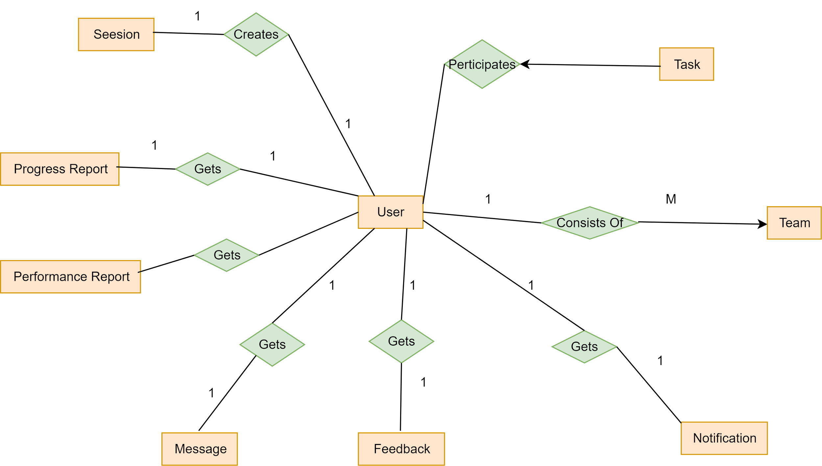](https://app.diagrams.net/?page-id=JpXTCvFZmwz3V7EVB828&scale=auto#G1e5l0_OCLXisfuB98qSUxReyMX_fn40B5)



Figure 11: TimeWise Entity Relationship Diagram

5. Class Based Modeling

5.1 What is Class Based Modeling?

Class-based modeling is a technique used in software development to represent the structure of a system by defining **classes**, their **attributes**, and their **relationships**. A class encapsulates data (attributes) and behaviors (methods) into a single entity, serving as a blueprint for objects in object-oriented programming. This model helps in visualizing how different parts of a system interact with each other.

5.2 Class Based Modeling: TimeWise

5.2.1 List of Nouns and Related Verbs

| No. | Nouns | Related Verbs |
| --- | --- | --- |
| 01 | User | Create, Manage, Update, Delete, Authenticate, Login, Logout, Register, View Profile, Interact, Collaborate |
| 02 | Student | Register, Manage Tasks, View Stats, Track Progress, Receive Notifications, Collaborate |
| 03 | Teacher | Register, Manage Tasks, View Stats, Assign, Collaborate, Provide Feedback |
| 04 | Manager | Assign, Track, Evaluate, Collaborate, Manage Tasks, Review, Provide Feedback |
| 05 | Employee | Register, Update, Manage Tasks, Track Progress, Provide Feedback |
| 06 | Working Professional | Manage Tasks, Track, View Stats, Collaborate, Receive Notifications |
| 07 | Others | Register, Manage Tasks, Track Progress, Collaborate, View Stats |
| 08 | Task | Create, Update, Delete, Assign, Track, Prioritize, Share, Complete, Modify, Comment |
| 09 | Progress | Track, Record, Evaluate, Update, Visualize |
| 10 | Performance | Evaluate, Track, Record, Analyze, Improve |
| 11 | Notification | Send, Receive, Track, Read, Acknowledge |
| 13 | Stats | Generate, View, Analyze, Interpret |
| 14 | Goal | Set, Track, Achieve, Edit, Evaluate, Complete |
| 15 | Team | Create, Manage, Update, Collaborate, Share |
| 16 | Feedback | Provide, Receive, Analyze, Track |
| 17 | Feedback Type | Select, Categorize |
| 18 | Role | Assign, Change, Manage |
| 19 | Category | Assign, Filter, Organize |
| 20 | Session | Start, End, Track, Analyze |
| 21 | TimeWise | Develop, Deploy, Manage, Use, Maintain |
| 22 | SIgn In | Authenticate, Validate |
| 23 | Sign Up | Register, Create Account |
| 24 | Account | Create, Update, Delete, Manage |
| 25 | Authentication | verify,check |
| 26 | Deadline | Set, Track, Extend, Adjust |
| 27 | Priority | Set, Adjust, Change |
| 28 | Comments | Add, Edit, Delete, View |
| 29 | Timer | Start, Stop, Track, Adjust |
| 30 | Productivity Meter | Track, Display, Measure |
| 31 | Task Sharing | Share, Collaborate, Modify, View |
| 32 | Task Administration | Administer, Approve, Modify, Track, Delete |
| 33 | Analytics Engine | Analyze, Generate Reports, Track, Process |
| 34 | User Dashboard | View, Update, Manage |
| 35 | Date and time service | Track, Adjust, Provide |
| 36 | Goal tracking | Track, Analyze, Update |
| 37 | Progress Analytics | Analyze, Track, Interpret |
| 38 | Performance Analytics | Analyze, Track, Visualize |
| 39 | Reporting service | Generate, Deliver, Track |
| 40 | Performance logs | Record, Store, Track |
| 41 | Statistics engine | Process, Analyze, Generate |
| 42 | Visualization service | Render, Display, Update |
| 43 | Focus timer service | Start, Stop, Track, Adjust |
| 44 | Efficiency analytics | Analyze, Track, Improve |
| 45 | Session Analytics | Analyze, Track, Summarize |
| 46 | Task status | Update, View, Track |
| 47 | Collaboration engine | Facilitate, Manage, Coordinate |
| 48 | Central database | Store, Retrieve, Update, Manage |
| 49 | Task completion stats | Track, Record, Display |
| 50 | Time spent stats | Track, Analyze, Summarize |
| 51 | Category based stats | Generate, Track, Display |
| 52 | Progress reports | Generate, View, Track |
| 53 | System Services | Provide, Integrate, Manage |

5.2.2 General Classifications

Candidate classes are categorized based on the seven general classification. The analysis classes manifest themselves in one of the following ways:

1. External entities

2. Things

3. Events

4. Roles

5. Organizational units

6. Places

7. Structures

A candidate class is selected for special classification if it fulfills three or more characteristics

| **No.** | **Nouns** | **General Classification** |
| --- | --- | --- |
| 01 | User | 1, 4, 5 |
| 02 | Student | 1, 4, 5 |
| 03 | Teacher | 1, 4, 5 |
| 04 | Manager | 1, 4, 5 |
| 05 | Employee | 1, 4, 5 |
| 06 | Working Professional | 1, 4, 5 |
| 07 | Others | 1, 4 |
| 08 | Task | 2, 3, 4 |
| 09 | Progress | 3 |
| 10 | Performance | 3 |
| 11 | Notification | 3 |
| 12 | Reminder | 3 |
| 13 | Stats | 3 |
| 14 | Goal | 3 |
| 15 | Team | 1, 4, 5 |
| 16 | Feedback | 3, 5 |
| 17 | Feedback Type | 4 |
| 18 | Role | 4 |
| 19 | Category | 2 |
| 20 | Session | 3 |
| 21 | TimeWise | 1, 2, 5 |
| 22 | SIgn In | 3 |
| 23 | Sign Up | 3 |
| 24 | Account | 2 |
| 25 | Authentication | 2,3,5 |
| 26 | Deadline | 3 |
| 27 | Priority | 3 |
| 28 | Comments | 3 |
| 29 | Timer | 3 |
| 30 | Productivity Meter | 3, 6 |
| 31 | Task Sharing | 2, 3 |
| 32 | Task Administration | 1, 4, 5 |
| 33 | Analytics Engine | 1, 2, 7 |
| 34 | User Dashboard | 2, 5, 7 |
| 35 | Date and time service | 2, 3, 5 |
| 36 | Goal tracking | 2, 3 |
| 37 | Progress Analytics | 2, 3, 5 |
| 38 | Performance Analytics | 2, 3, 5 |
| 39 | Reporting service | 2, 3, 5 |
| 40 | Performance logs | 3 |
| 41 | Statistics engine | 2, 5, 7 |
| 42 | Visualization service | 2, 5 |
| 43 | Focus timer service | 2, 3 |
| 44 | Efficiency analytics | 2, 3, 5 |
| 45 | Session Analytics | 2, 3, 5 |
| 46 | Task status | 2, 3 |
| 47 | Collaboration engine | 1, 2, 5 |
| 48 | Central database | 2, 5, 7 |
| 49 | Task completion stats | 3, 6 |
| 50 | Time spent stats | 3, 6 |
| 51 | Category based stats | 3, 5 |
| 52 | Progress reports | 2, 3, 5 |
| 53 | System Services | 1, 2, 5 |

5.2.3 Selection Criteria

The candidate classes are then selected as classes by six Selection Criteria:

1. Retain information

2. Needed services

3. Multiple attributes

4. Common attributes

5. Common operations

6. Essential requirements

A candidate class generally becomes a class when it fulfills around three characteristics.

| No | Potential Classes | Selection Criteria |
| --- | --- | --- |
| 01 | User(Student,Teacher,Working Professional,Employee,Managers,Others) | 1, 3, 5, 6 |
| 02 | Task | 1, 2, 3, 5 |
| 03 | Progress | 1, 3, 5 |
| 04 | Performance | 1, 2, 3, 5, 6 |
| 05 | Authentication | 2, 5, 6 |
| 06 | Goal | 1, 2, 3, 5 |
| 07 | Team | 1, 2, 5, 6 |
| 08 | Feedback | 1, 3, 6 |
| 09 | Session | 1, 2, 5 |
| 10 | Account | 1, 5 |
| 11 | Analytics Engine  (Session Analytics, Progress Analytics, Performance Analytics,Efficiency Analytics) | 1, 2, 3, 5 |
| 12 | User Dashboard | 2 |
| 13 | System Services  (Date Time Service, Reporting Service, Visualization Service) | 2, 5, 6 |
| 14 | Progress Report | 1, 5 |
| 15 | Statistics Engine | 1, 2, 3, 5 |
| 16 | Collaboration Engine | 1, 2, 3, 5 |
| 17 | Focus Timer Service | 1, 2, 6 |
| 18 | Performance Report | 1, 5 |
| 19 | Task Administration | 1, 2, 6 |
| 20 | Task Completion Stats | 4, 5 |
| 21 | Time Spent Stats | 4, 5 |
| 22 | Category Based Stats | 4, 5 |
| 23 | Performance Logs | 4, 5 |
| 24 | Comments | 4, 5 |
| 25 | Admin | 1, 3, 5, 6 |
| 26 | Productivity Meter | 4, 5 |
| 27 | Timer | 4, 5 |
| 28 | Notification | 1, 3, 5 |

5.2.4 Selected Classes

There are 17 main and central classes in this system:

| **Selected Classes** |
| --- |
| User  (Student,Teacher,Manager,Employee,Working Professional,Other) |
| Task |
| Progress |
| Performance |
| Notification |
| Team |
| Feedback |
| Goal |
| Session |
| Focus Timer Service |
| Task Administration |
| Analytics Engine  (Session Analytics, Progress Analytics, Performance Analytics,Efficiency Analytics) |
| System Services  (Date Time Service, Reporting Service, Visualization Service) |
| Collaboration Engine |
| Statistics Engine |
| Authentication |

5.3 Class-Card

### **1. User**

* **Attributes**:
  + Name (String)
  + Email (String)
  + Phone Number (String)
  + Gender (String)
  + FingerPrintData (Structure)
  + Date of Birth (Structure)
  + Role (Student, Teacher, Manager, Employee, Working Professional, Other)
  + Short Biodata (String)
  + User Status (Active, Inactive)
* **Methods**:
  + **Register()**: Register individual information.
  + **SetPassword()**: Set a password for the registered account (Admin responsibility).
  + **Authenticate()**: Authenticate whenever logged in (Admin responsibility).
  + **updatePersonalInformation()**: Update personal data (Admin responsibility).
* **Responsibilities**:
  + Responsible for registering personal data, maintaining user status, and managing tasks.
* **Collaboration**:
  + Collaborates with all the other modules and classes of the system to manage tasks.

### **2. Task**

* **Attributes**:
  + Task_ID (Primary Key)
  + Task Name (String)
  + Task Description (String)
  + Task Priority (String)
  + Task Deadline (Date)
  + Task Owner (User_ID)
  + Task Participants (list of User_IDs)
  + Task Status (String)
  + Task Creation Date (Date)
  + Task Modification Date (Date)
  + Task Comments (String)
  + Task Category (String)
* **Methods**:
  + **CreateTask()**: Create a new task.
  + **UpdateTask()**: Update task details.
  + **AssignTask()**: Assign tasks to a user.
  + **ChangeTaskStatus()**: Change the status of the task (e.g., Pending, In Progress, Completed).
  + **AddComments()**: Add comments to the task.
* **Responsibilities**:
  + Responsible for managing tasks, including creation, updates, assignment, and status changes.
* **Collaboration**:
  + Collaborates with **User** to assign tasks and manage progress.
  + Administered by **Admin** for any system-level changes or critical updates.

### 

### **3. Progress Report**

* **Attributes**:
  + Progress_ID (Primary Key)
  + User_ID (Foreign Key)
  + Task_ID (Foreign Key)
  + Progress Amount (Float)
  + Progress History (List of logs)
  + Progress Report (String)
* **Methods**:
  + **TrackProgress()**: Track the user's progress on a task.
  + **UpdateProgress()**: Update progress details based on user input.
  + **GenerateProgressReport()**: Generate a progress summary report.
* **Responsibilities**:
  + Responsible for tracking and reporting the progress of assigned tasks.
* **Collaboration**:
  + Collaborates with **Users** to update and track their progress on specific tasks.
  + Linked with **Task** for progress tracking on specific tasks.

### **4. Performance Report**

* **Attributes**:
  + Performance_ID (Primary Key)
  + User_ID (Foreign Key)
  + Performance History (List of records)
  + Performance Score (Float)
  + Performance Report (String)
* **Methods**:
  + **EvaluatePerformance()**: Evaluate the user’s performance over a defined period.
  + **GeneratePerformanceReport()**: Generate a performance analysis report.
* **Responsibilities**:
  + Responsible for tracking and evaluating the overall performance of users based on completed tasks.
* **Collaboration**:
  + Collaborates with **Users** to evaluate their performance.
  + Uses **Task** data for performance scoring and analysis.

### **5. Notification**

* Attributes:
  + Notification_ID (Primary Key)
  + User_ID (Foreign Key)
  + Notification Type
  + Notification Message
  + Notification Status
  + Timestamp
* **Methods:**
  + CreateNotification()
  + UpdateStatus()
  + DeleteNotification()
* **Responsibilities:**
  + Responsible for managing notifications sent to users.
  + Responsible for updating and tracking the status of notifications.
* **Collaboration:**
  + Collaborates with User to send notifications and update their status.
  + Works with Admin to manage the delivery and status of notifications.

### **7. Team**

* **Attributes:**
  + Team_ID (Primary Key)
  + Team Name
  + Team Members
  + Created By
  + Creation Date
  + Team Status
* **Methods:**
  + CreateTeam()
  + UpdateTeam()
  + DeleteTeam()
* **Responsibilities:**
  + Responsible for managing team creation, member assignments, and status updates.
  + Responsible for ensuring teams are active and their members are tracked.
* **Collaboration:**
  + Collaborates with User to assign team members and manage team details.
  + Collaborates with Admin for team-related administrative tasks.

### 

### 

### **8. Feedback**

* **Attributes:**
  + Feedback_ID (Primary Key)
  + User_ID (Foreign Key)
  + Feedback Type
  + Feedback Message
  + Date Submitted
  + Rating
* **Methods:**
  + SubmitFeedback()
  + UpdateFeedback()
  + DeleteFeedback()
* **Responsibilities:**
  + Responsible for collecting and managing user feedback.
  + Responsible for ensuring feedback is properly tracked and stored.
* **Collaboration:**
  + Collaborates with **User** to collect feedback and manage its submission.
  + Collaborates with **Analytics Engine** to give personalized feedback.

### **10. Session**

* **Attributes**:
  + Session_ID (Primary Key)
  + User_ID (Foreign Key)
  + Session Start Time
  + Session End Time
  + Duration
  + Activity Summary
* **Methods**:
  + StartSession()
  + EndSession()
  + UpdateSession()
* **Responsibilities**:
  + Responsible for tracking user sessions, including start and end times, activity, and duration.
  + Responsible for summarizing the activity performed during the session.
* **Collaboration**:
  + Collaborates with **User** to log and track session details.
  + Works with **Focus Timer Service** to track the duration of focus sessions.

### **14. Analytics Engine**

* **Attributes**:
  + Analytics Engine ID (Primary Key)
  + User_ID (Foreign Key)
  + Analytics Engine Type (e.g., Session Analytics, Progress Analytics, Performance Analytics, Efficiency Analytics)
  + Insight
  + Generated Report
  + Analysis Type (e.g., Efficiency, Time Spent)
  + Data Source (e.g., Tasks, Activities)
* **Methods**:
  + GenerateReport()
  + AnalyzeData()
  + ProvideInsights()
* **Responsibilities**:
  + Responsible for analyzing user activities and generating insights and reports.
  + Responsible for providing detailed analytics based on user sessions, performance, and progress.
* **Collaboration**:
  + Collaborates with **User** for personalized analysis and feedback.
  + Works with **System Services** to visualize data and generate comprehensive reports.

### **15. System Services**

* **Attributes**:
  + Service_ID (Primary Key)
  + Analytics Engine ID (Foreign Key)
  + Service Type (e.g., Date Time Service, Reporting Service, Visualization Service)
  + Data Source (e.g., Tasks, Activities)
* **Methods**:
  + ProvideDateTimeService()
  + GenerateReportService()
  + VisualizeData()
  + authenticate()
  + authorize()
* **Responsibilities**:
  + Responsible for offering system services like date-time management, data reporting, and data visualization.
  + Responsible for supporting the Analytics Engine with service-based data processing.
  + Responsible for authentication of users.
* **Collaboration**:
  + Collaborates with **Analytics Engine** to process and visualize data for user analysis.

### **16. Collaboration Engine**

* **Attributes**:
  + Collaboration_ID (Primary Key)
  + User_IDs (List of participants)
  + Collaboration Type (e.g., Group Project, Task Collaboration)
  + Creation Date
  + Status (e.g., Active, Completed)
* **Methods**:
  + InitiateCollaboration()
  + ManageCollaboration()
  + TrackCollaborationProgress()
* **Responsibilities**:
  + Responsible for facilitating collaboration between multiple users for projects and tasks.
  + Manages and tracks the progress and status of collaborations.
* **Collaboration**:
  + Collaborates with **User** entities to involve participants in tasks or projects.
  + Works with **Task Administration** to oversee tasks assigned to collaborative groups.

### **17. Statistics Engine**

* **Attributes**:
  + StatEngine_ID (Primary Key)
  + User_ID (Foreign Key)
  + Stat Type (e.g., Task Completion, Time Spent)
  + Calculation Date
  + Stat Value
* **Methods**:
  + CalculateStatistics()
  + GenerateStatReport()
* **Responsibilities**:
  + Responsible for collecting, calculating, and analyzing statistics related to user activities.
  + Generates reports and provides statistical insights.
* **Collaboration**:
  + Collaborates with **User** for personalized statistical reports and analysis.
  + Works with **Analytics Engine** to provide statistical data for deeper insights and performance evaluation.

5.4 Class Responsibility(CRC) Diagram

[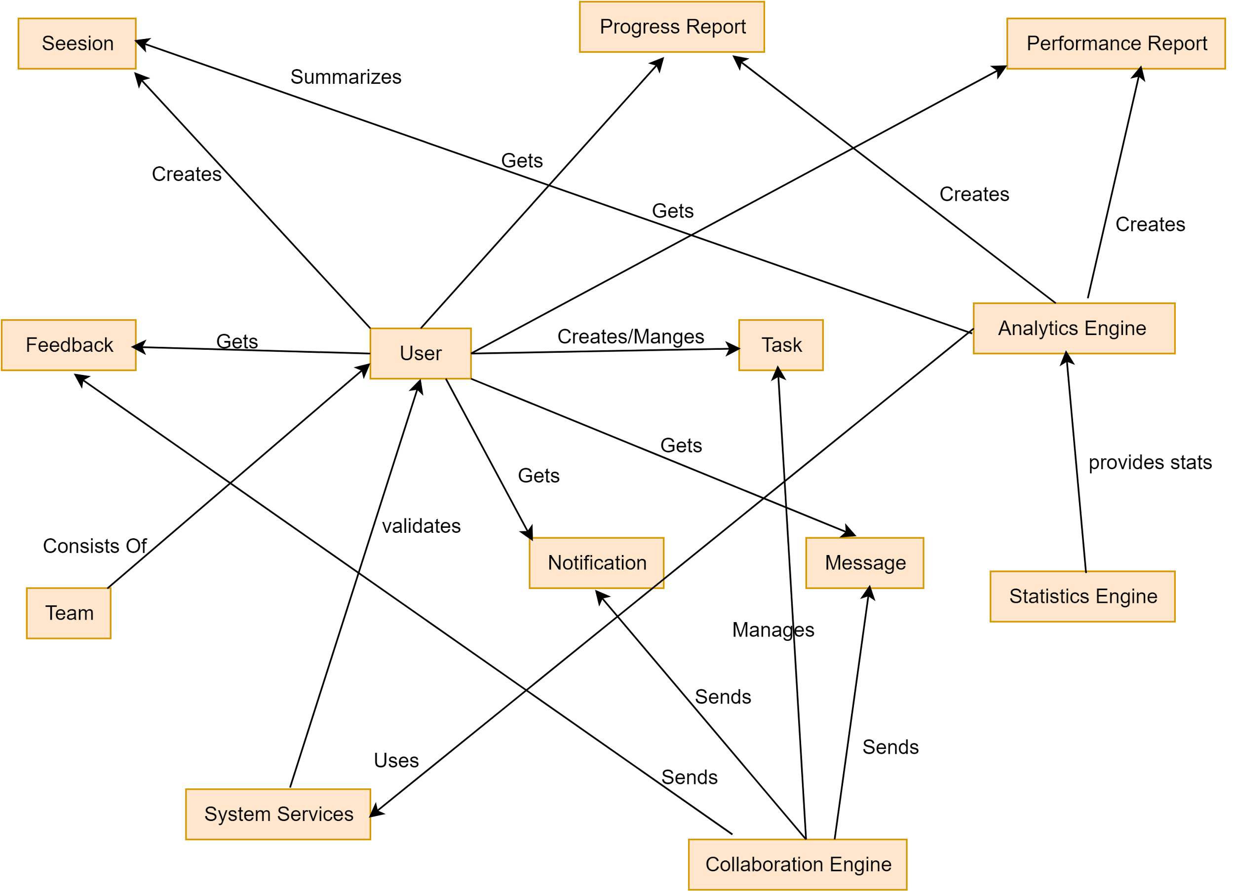](https://app.diagrams.net/?page-id=3EuqdE2Nsrsw9YRPW36l&scale=auto#G1RbcvLhmWMsykcjEAlYDjA8eqpI8_-lL2)

Figure 12: TimeWise CRC Diagram

7. Behavioral Modeling

The behavioral model indicates how the software will respond to external events or stimuli. In the context of behavioral modeling, two different characterizations of states must be considered: (1) the state of each class as the system performs its function and (2) the state of the system as observed from the outside as the system performs its function.

The behavioral modeling of TimeWise provides insights into how the system responds to external events, emphasizing both the state of individual classes and the overall system state. Below is a breakdown of the UML State Transition Diagram and a detailed list of events, focusing on the interactions between users, admins, and system components.

### 7.1 State Transition Diagram for TimeWise

The State Transition Diagram represents the active states of core classes in TimeWise and the events (triggers) that cause transitions. The states are represented as rectangles, and transitions are represented by arrows with labels for the corresponding events.

7.1.1 List of Events

### **1. User Events**

* Registers in the system
* Logs into the system
* Adds a task (Collaborator: Task).
* Updates task details (Collaborator: Task).
* Completes a task (Collaborator: Progress).
* Requests performance insights (Collaborator: Performance).
* Sets reminders (Collaborator: Notification).
* Receives notifications (Collaborator: Notification).
* Joins a team (Collaborator: Team).
* Provides feedback (Collaborator: Feedback).
* Creates a goal (Collaborator: Goal).
* Starts a session (Collaborator: Session).
* Starts a focus timer (Collaborator: Focus Timer Service).
* Share tasks with others (Collaborator: Collaboration Engine).
* Configures notifications (Collaborator: Notification).
* Manages team memberships (Collaborator: Team).
* Reviews user feedback (Collaborator: Feedback).
* Oversees goals and progress (Collaborators: Goal, Progress).

### **2. Task Events**

* Marks a task as completed (Collaborator: Progress).
* Updates task status (Collaborators: Performance, Notification).
* Tracks overdue tasks (Collaborators: Notification).

### **4. Progress Events**

* Tracks task progress (Collaborators: Task, Goal).
* Updates progress report (Collaborator: Performance).

### **5. Performance Events**

* Generates performance insights (Collaborators: Analytics Engine, Statistics Engine).
* Share performance with users (Collaborator: Notification).

### **6. Notification Events**

* Sends task updates to users (Collaborators: User, Task).
* Alerts about overdue tasks (Collaborators: Task).

### **7. Team Events**

* Adds a user to a team (Collaborator: User).
* Updates team information (Collaborators: Admin, User).

### **8. Feedback Events**

* Submits feedback (Collaborators: User, Task).
* Updates feedback (Collaborators: User).

### **9. Goal Events**

* Tracks goal progress (Collaborators: Progress, Task).
* Updates goal status (Collaborators: Performance, Notification).

### **11. Session Events**

* Logs session start and end time (Collaborator: User).
* Updates session data (Collaborator: Analytics Engine).

### **12. Focus Timer Service Events**

* Starts a focus timer session (Collaborators: User, Session).
* Tracks timer breaks (Collaborators: Session, Notification).

### **13. Task Administration Events**

* Updates task details (Collaborators: Admin, User).
* Shares task permissions (Collaborator: Collaboration Engine).

### **14. Analytics Engine Events**

* Generates session analytics (Collaborators: Session, Statistics Engine).
* Provides performance analytics (Collaborators: Performance, User).

### **15. System Services Events**

* Tracks time for notifications (Collaborators: Reminder, Notification).
* Visualizes task data (Collaborators: Analytics Engine, User).
* Manages reports (Collaborators: Admin, Statistics Engine).

### **16. Collaboration Engine Events**

* Invites users to collaborate (Collaborators: User, Task).
* Updates collaboration status (Collaborators: Team, Task Administration).

### **17. Statistics Engine Events**

* Tracks user productivity stats (Collaborators: Analytics Engine, Task).
* Generates user progress statistics (Collaborators: Progress, Performance).

**7.1.2 State Transition Diagram**

**ID: 1 (User)**

[****](https://app.diagrams.net/?page-id=jxRCyMqgudw7oCrJNsCl&scale=auto#G1_ixrFmcPDGy_rJO9xKBiXePddISjyXrN)

**ID: 2 (Task)**

[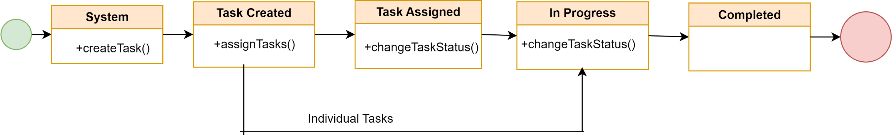](https://app.diagrams.net/?page-id=rKcpbLRIqAIxNCDWJMpR&scale=auto#G1w9edlzYzUDs5CztYEj3-CLzD5a3GbnDm)

**ID: 3 (Progress)**

[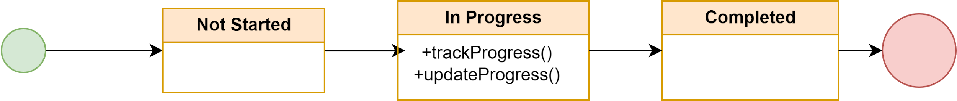](https://app.diagrams.net/?page-id=sLM2ll4cl57s2gwHTdVE&scale=auto#G1ERC7CrrL6O2CaKbhr8ARj9TM9AdyUPFr)

**ID: 4 (Performance)**

[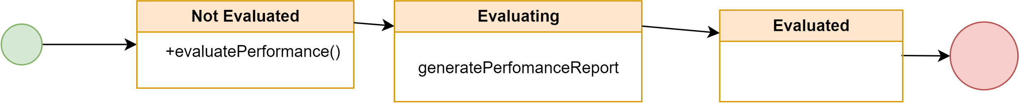](https://app.diagrams.net/?page-id=y3fPiE0jHA1bqCTlX0SU&scale=auto#G1fGZEQ0nsGdrC5M0nrqDFyLjMWH-VUufC)

**ID: 5 (Notification)**

[****](https://app.diagrams.net/?page-id=XGvFcA5mwoxWJ-QejIZL&scale=auto#G1WrxgQtvqO_LJlgr-FZLM5QaL2OASk9h-)

**ID: 7 (Team)**

[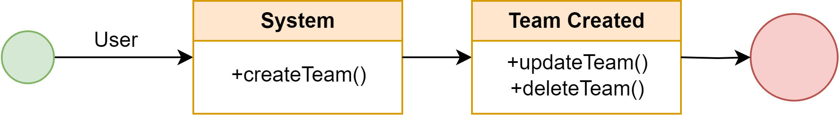](https://app.diagrams.net/?page-id=4_f1SY4lljTggQ_M4D_B&scale=auto#G1cRYni1u8zG5wvI3b8K5T4D1ptqJEEFLI)

**ID: 8 (Feedback)**

[****](https://app.diagrams.net/?page-id=WycexFzs9Zc_DDx2VqRs&scale=auto#G1wD_WzpmV9jeX5LRwOUKY4Qa6geDxUZ9X)

**ID: 9 (Goal)**

[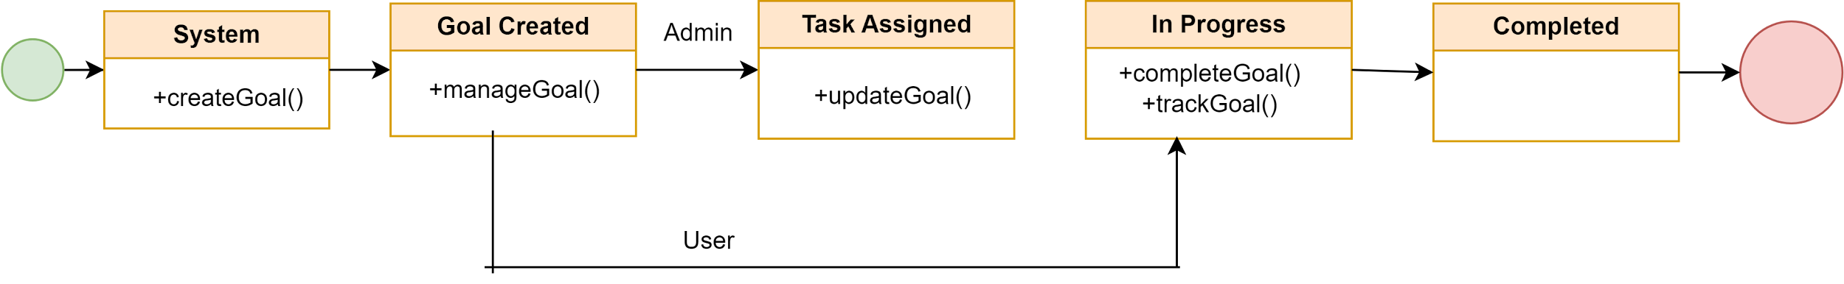](https://app.diagrams.net/?page-id=hTNn0EP_g7uTxumTFpnp&scale=auto#G1BOi6L1_UZJp-6rfJPnja37l7WA5zOJ0q)

**ID: 10 (Session)**

[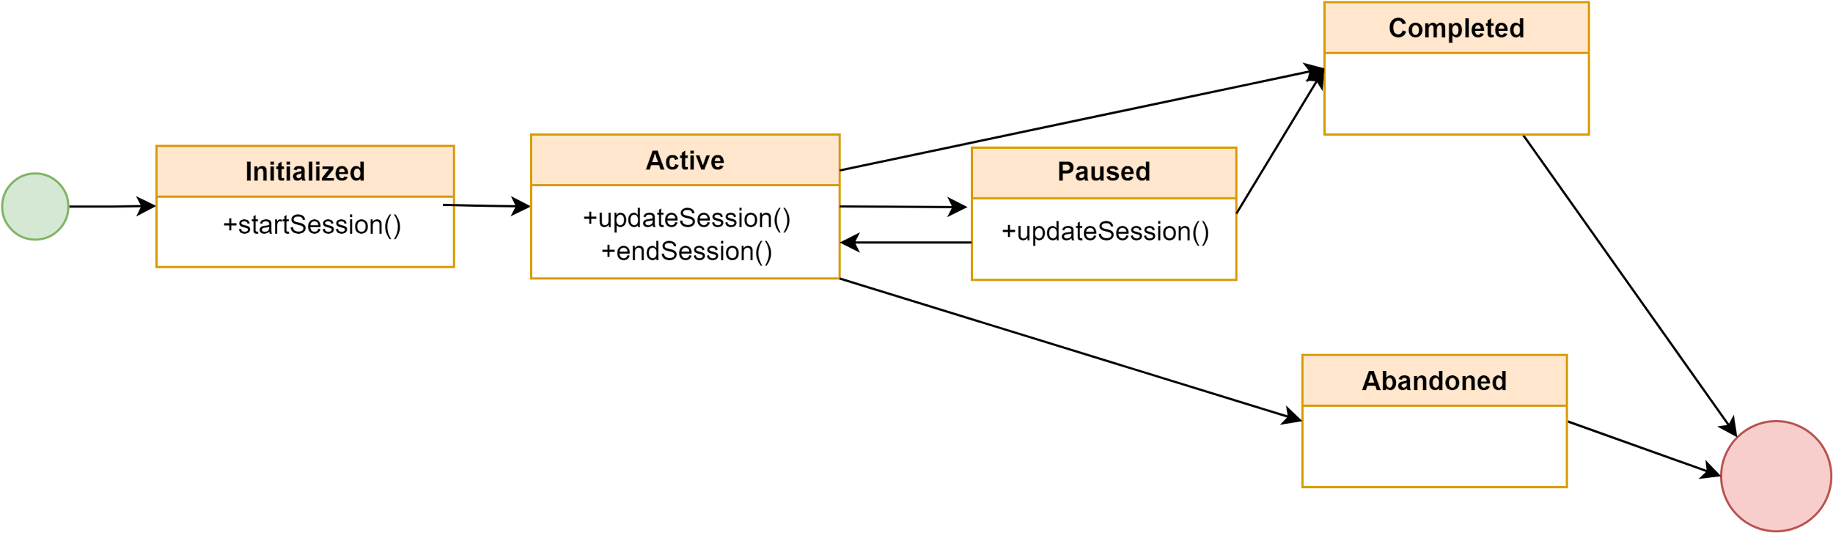](https://app.diagrams.net/?page-id=E-WB8SeYNhronzSsNpRF&scale=auto#G15e70R9QyJ-0-Y_kDPdZE-D8DrMpLbq-F)

**ID: 12 (Analytics Engine)**

[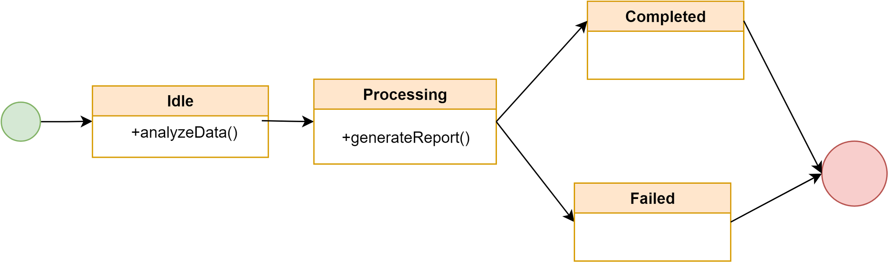](https://app.diagrams.net/?page-id=z3Egxmo4NJcvOkK2a_0e&scale=auto#G1EOOsVF0zfFgd49Ms7LCTia6-0bvanzoT)

**ID: 13 (System Services)**

[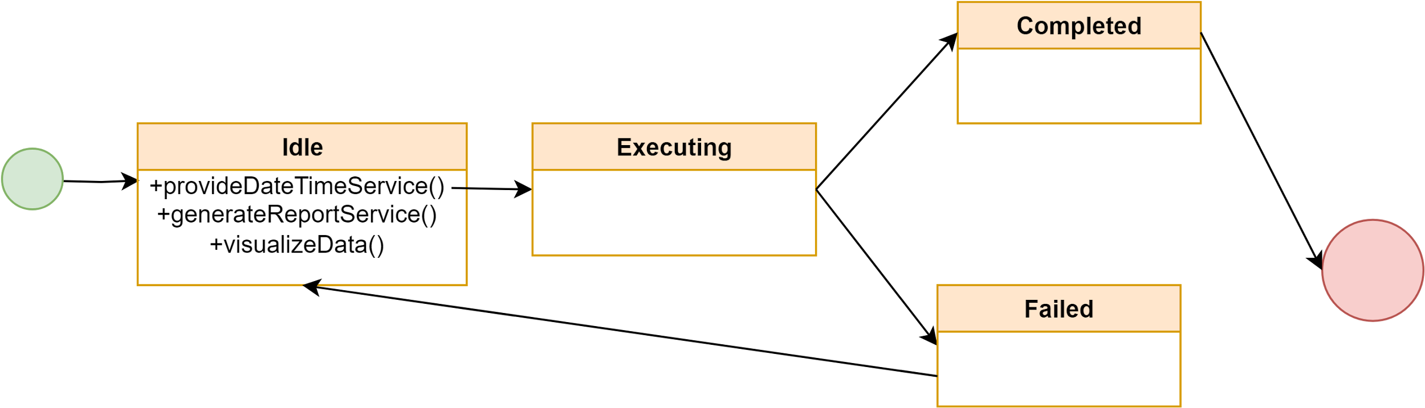](https://app.diagrams.net/?page-id=y0GVzNZUhxnF6UJl6xlr&scale=auto#G1DKRb6Kq_ufIZ31ELm-TxVsBmTbMOTh-d)

**ID: 14 (Collaboration Engine)**

[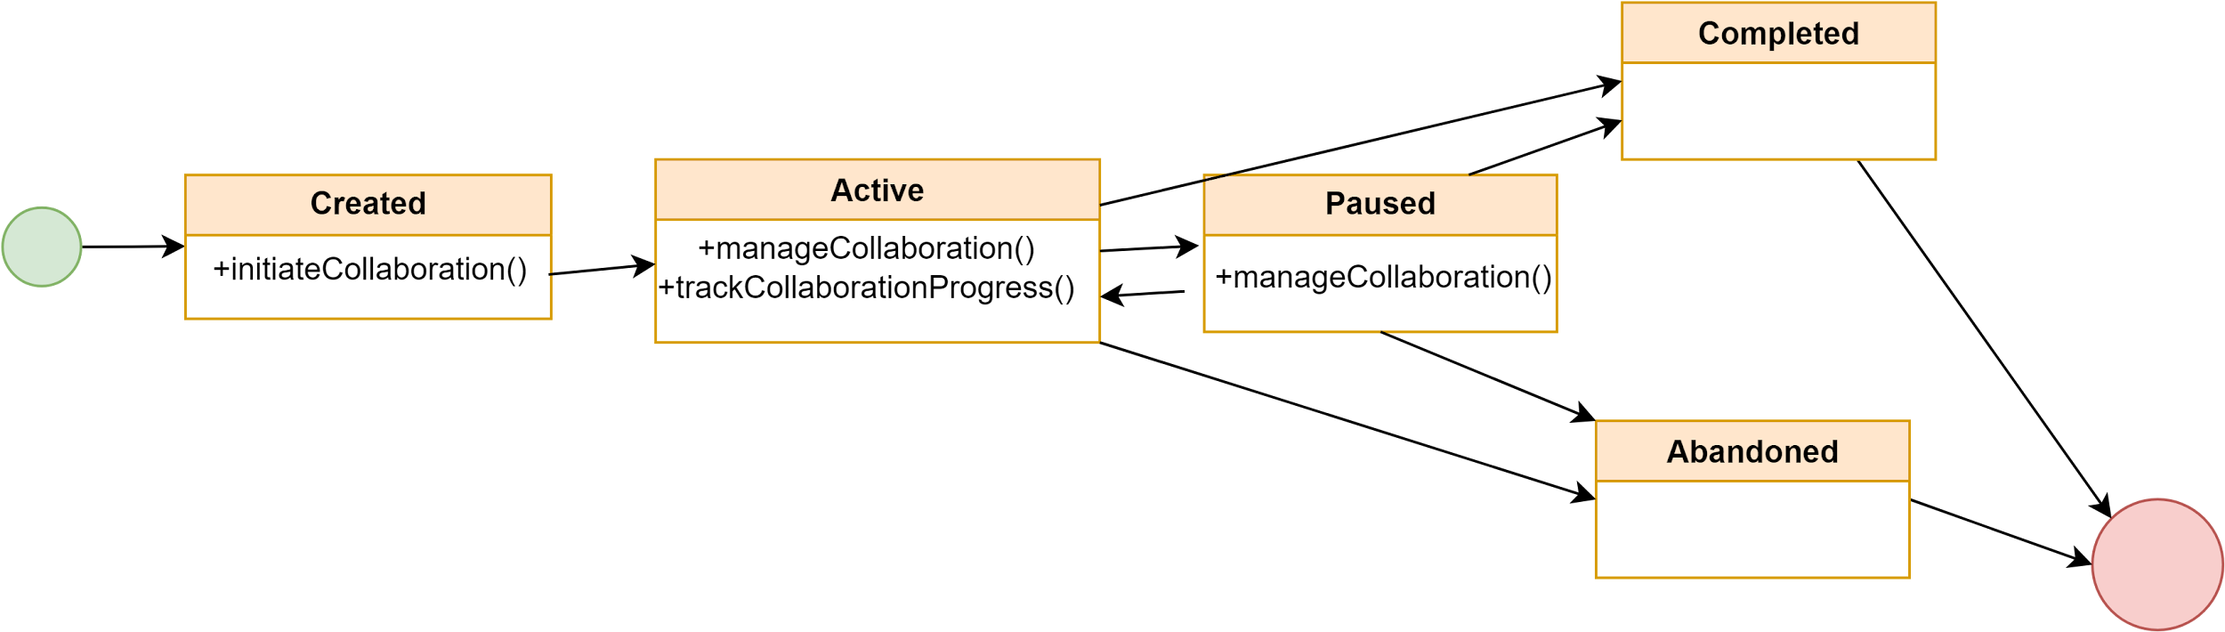](https://app.diagrams.net/?page-id=O2Px0PdjCel0pqvVl-ij&scale=auto#G1G97pI2HRLq5TlR2jC6UBZYhkHgQ2lcsO)

**ID: 15 (Statistics Engine)**

[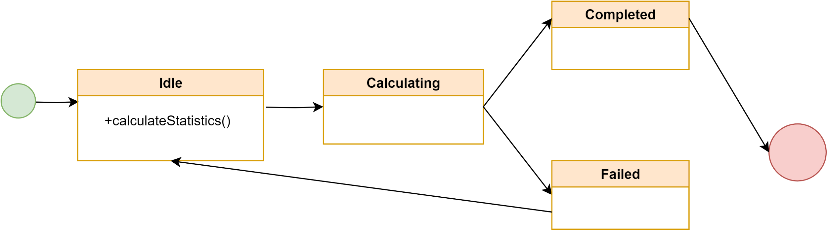](https://app.diagrams.net/?page-id=dnJqvBTewTbn9He8-6vC&scale=auto#G1lJPWsL8y3Yfofir_8iecXxuaTHTOgCU7)

7.2 Sequence Diagram:

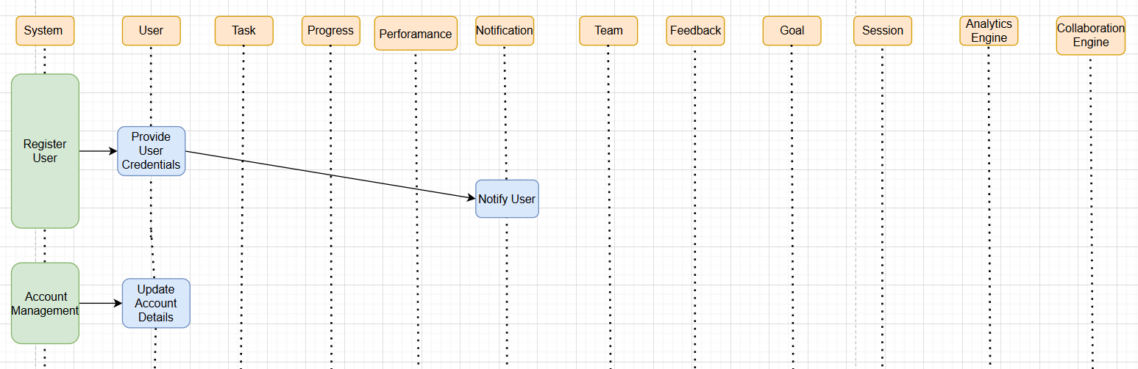

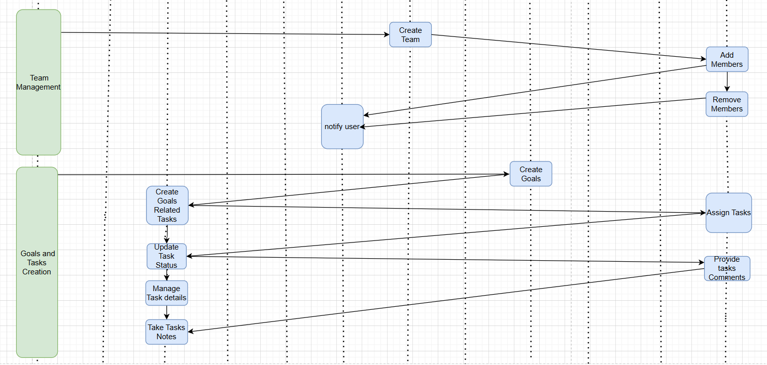

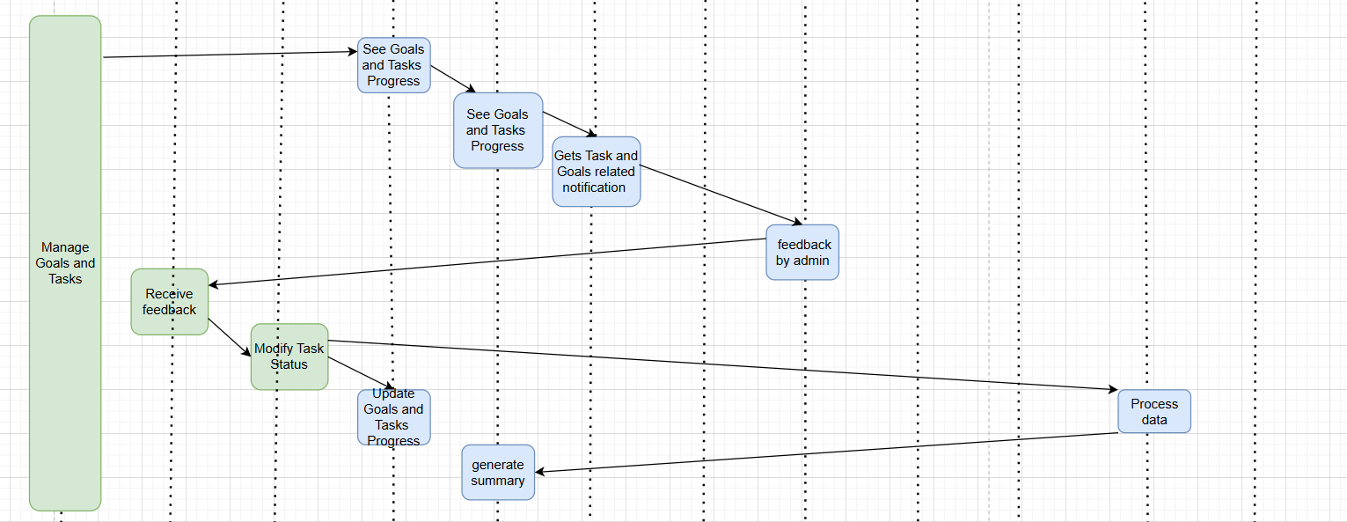

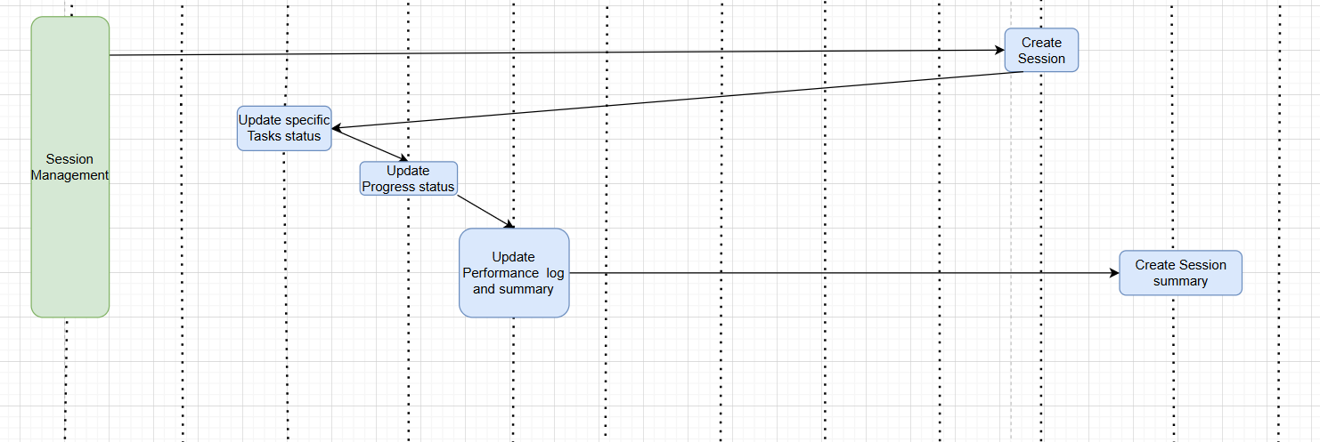

**8 DFD diagram:**

**Level 0:**

[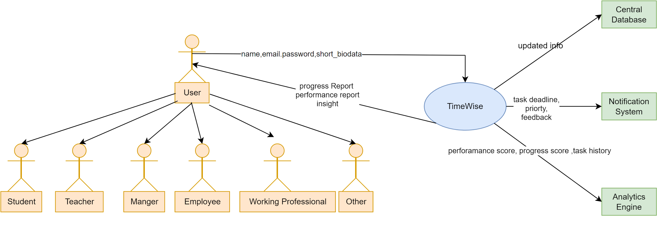](https://app.diagrams.net/?page-id=a2YNN41I2J4Gx2vtRvGo&scale=auto#G1Po40v3L57y321k62B4-T4IdBvO63KfFN)

**Level 1:**

[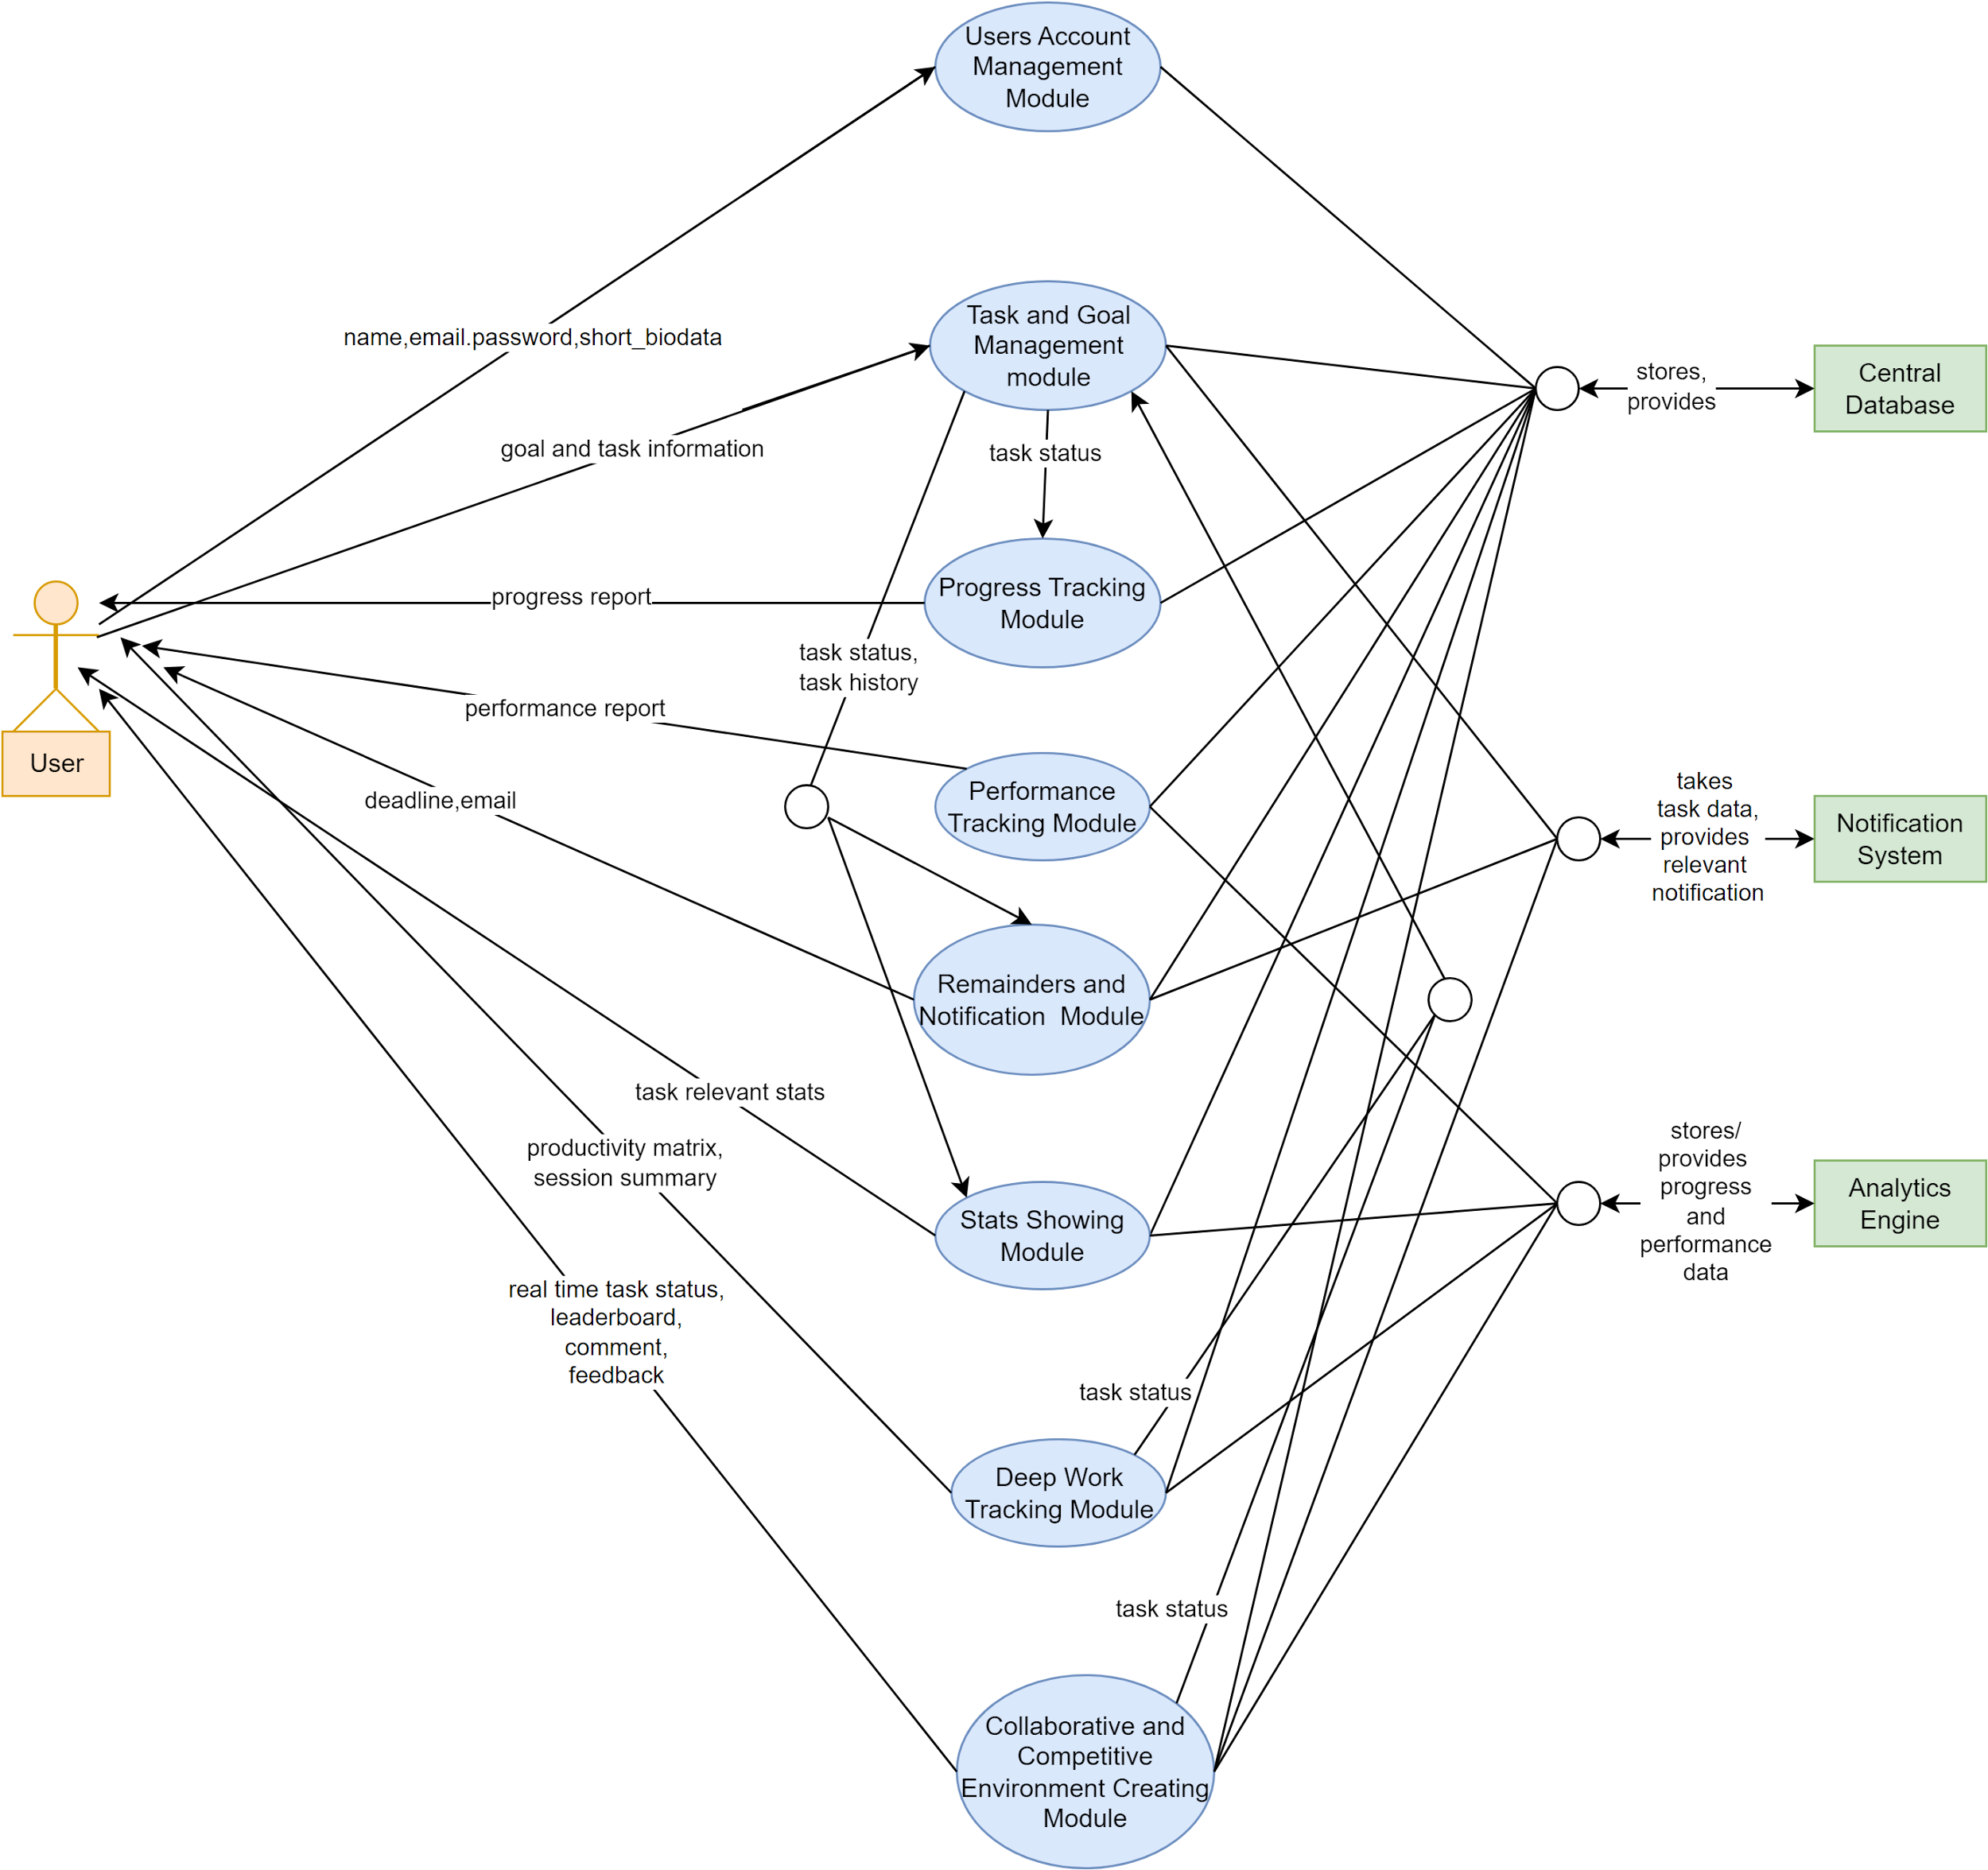](https://app.diagrams.net/?page-id=aE_dQklrNwHpYCPPT6lQ&scale=auto#G1bN1vMDLtqVBKHdpgWYd0FqqNj_f-6Mt0)

**Level 1.1:**

[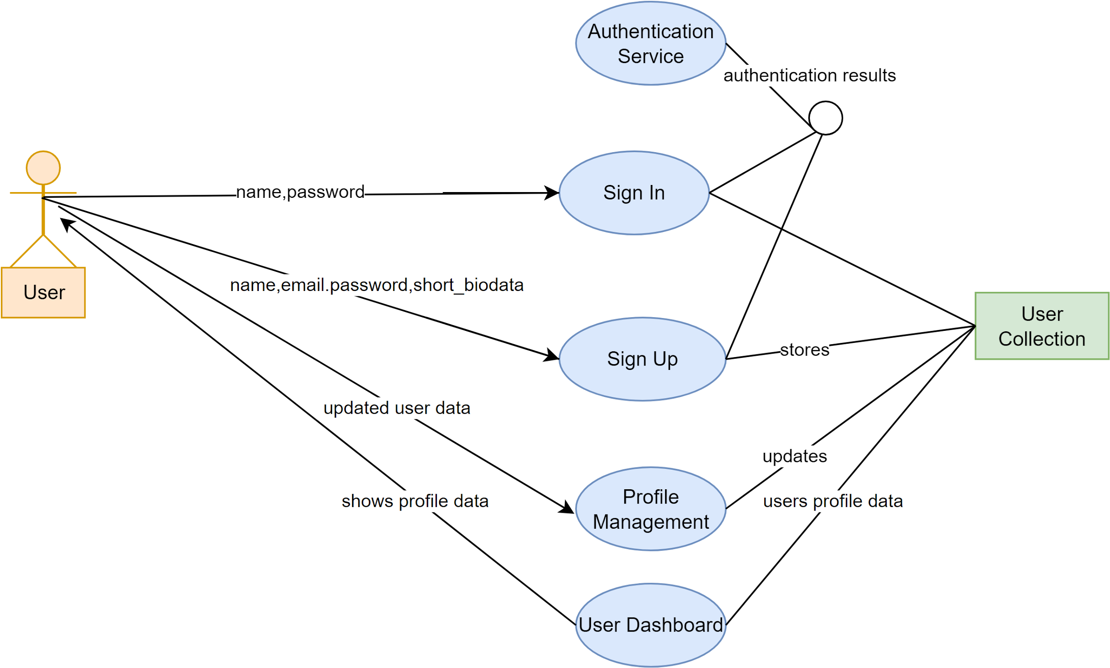](https://app.diagrams.net/?page-id=09OdgepF79jMHcbMWXLo&scale=auto#G19FzL6WJvH_DxH8vg_tLWXzVBLCYg89YT)

**Level 1.2:**

[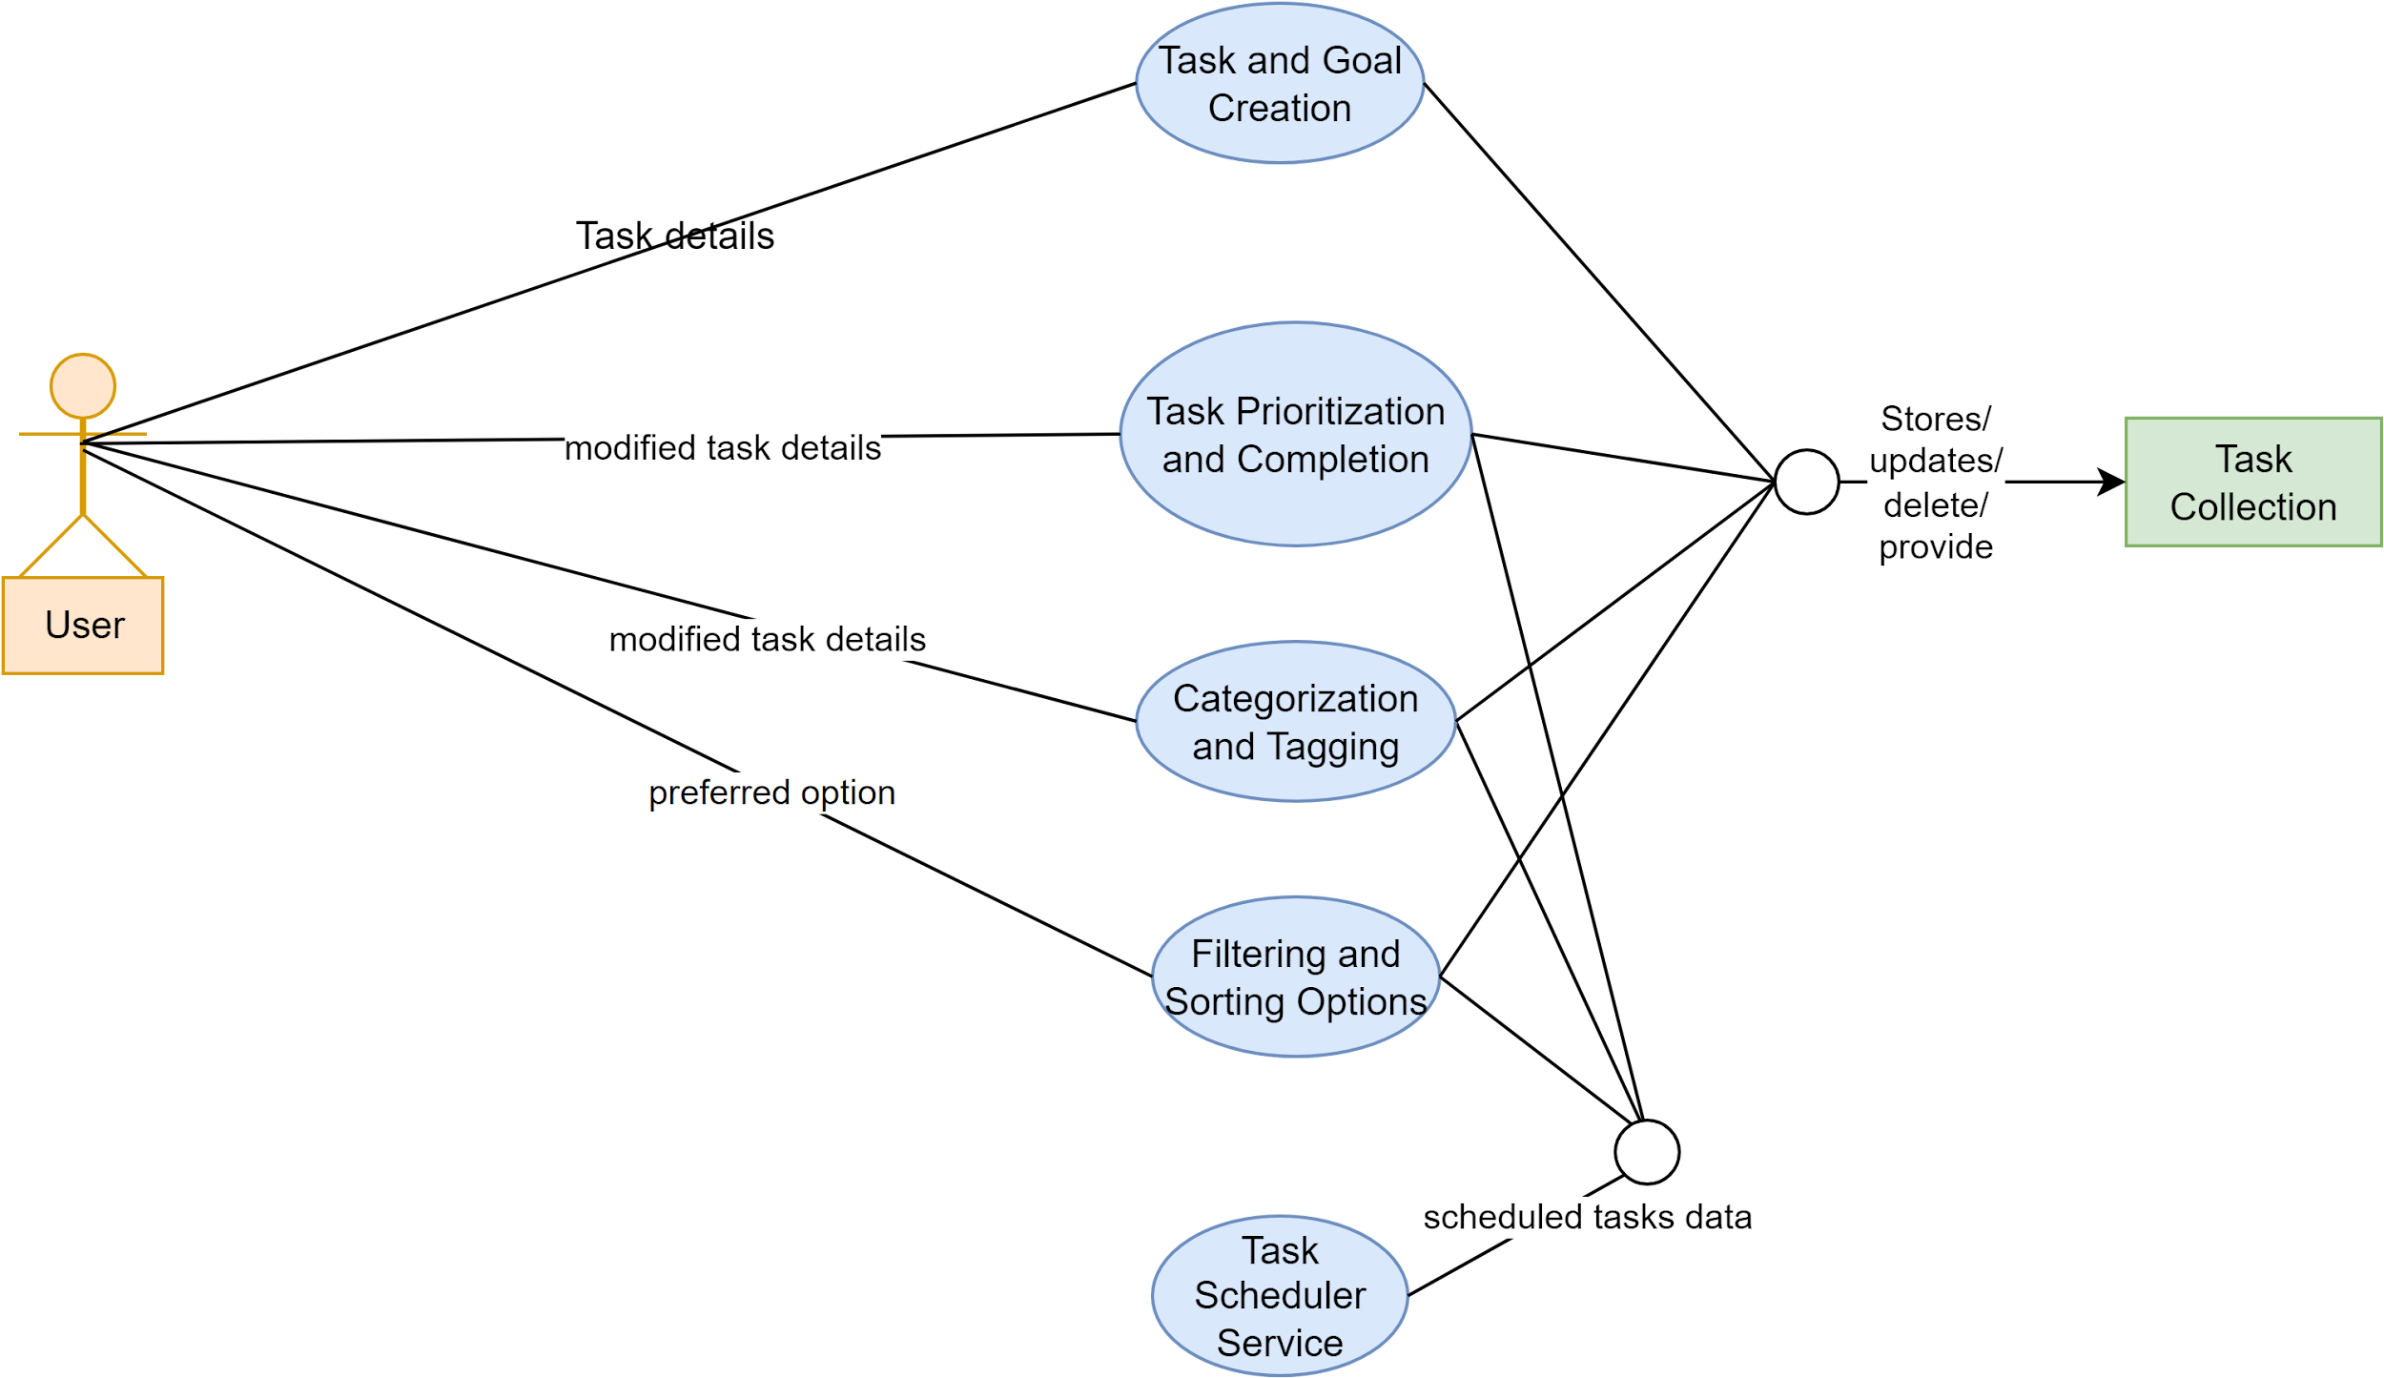](https://app.diagrams.net/?page-id=iUmQ64EPgQeWoGANH7fP&scale=auto#G1w2OQ3SP_CpHeogsrgtYlfFOS7hYf4P4E)

**Level 1.3:**

[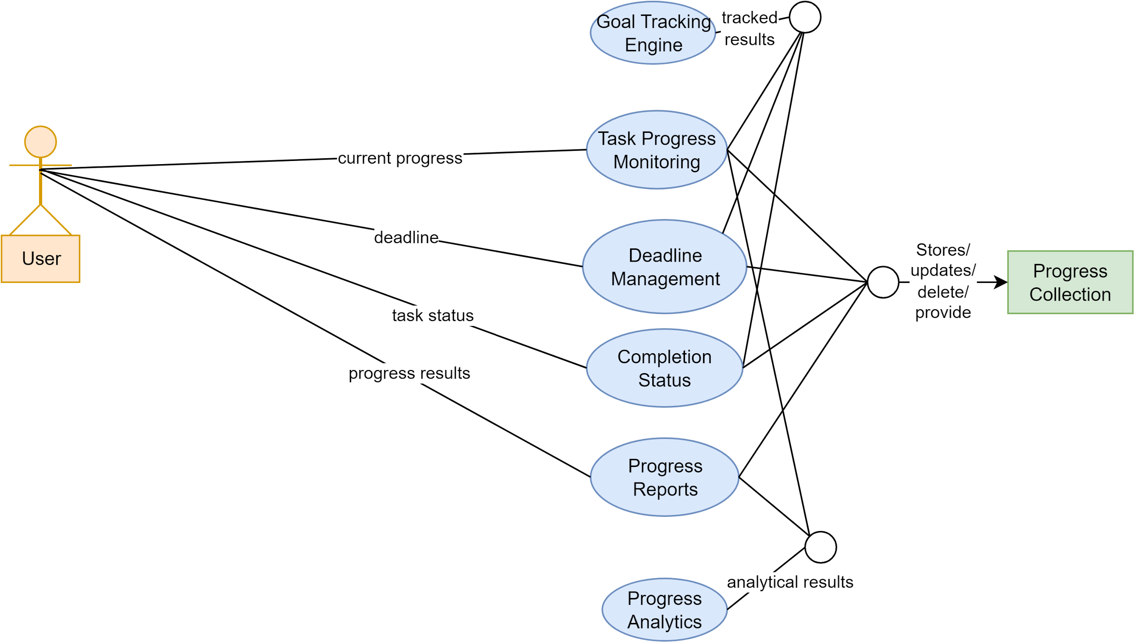](https://app.diagrams.net/?page-id=MFcPkU3_VCB9G_LMqk2t&scale=auto#G1wiWgA1LjvUkyQeMFsZqVth9L8nSK_8Ra)

**Level 1.4:**

[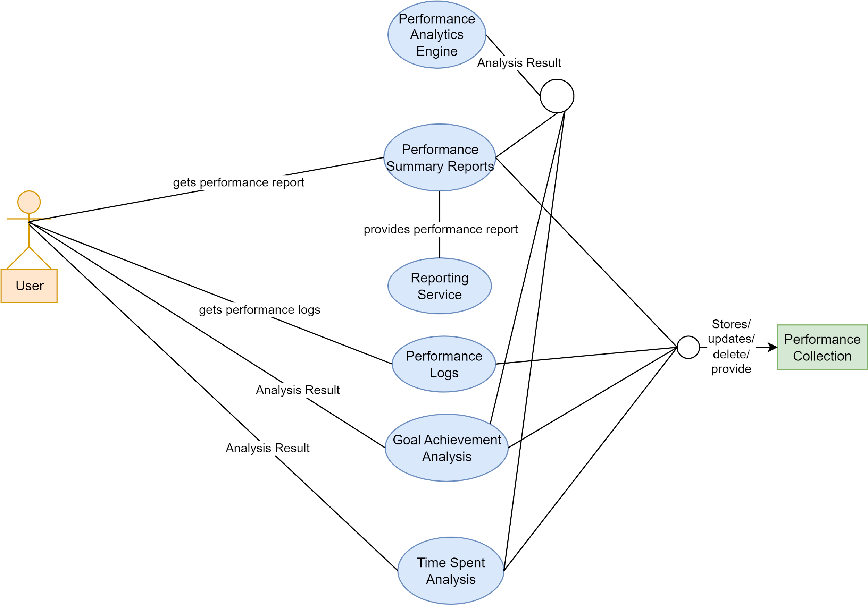](https://app.diagrams.net/?page-id=SVfDqrBpxlqZQ7HKxv8Y&scale=auto#G1b9LUcTGMSVb6bNbyytRVooBWrjVlIfOh)

**Message:**

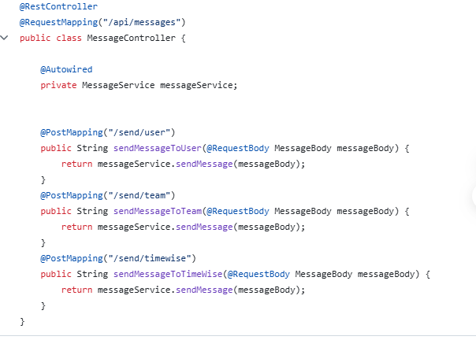

**Notification:**

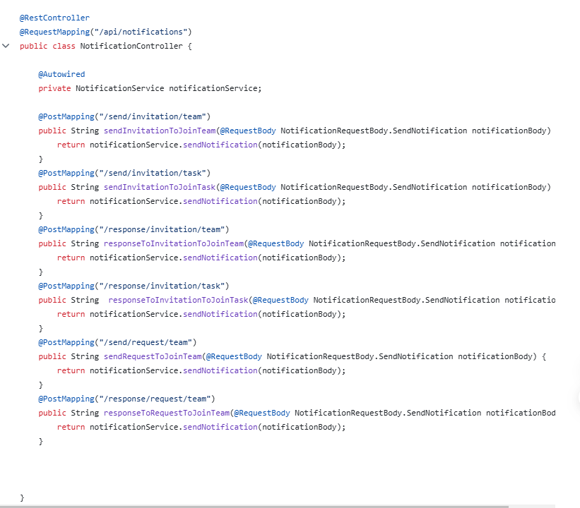

**Session:**

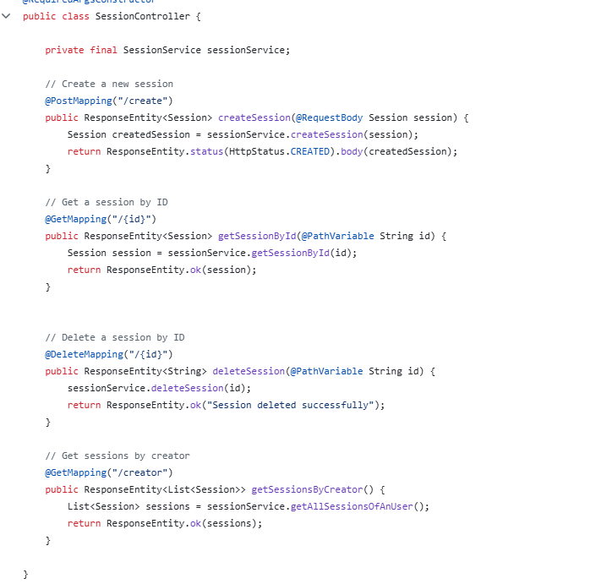

**User**

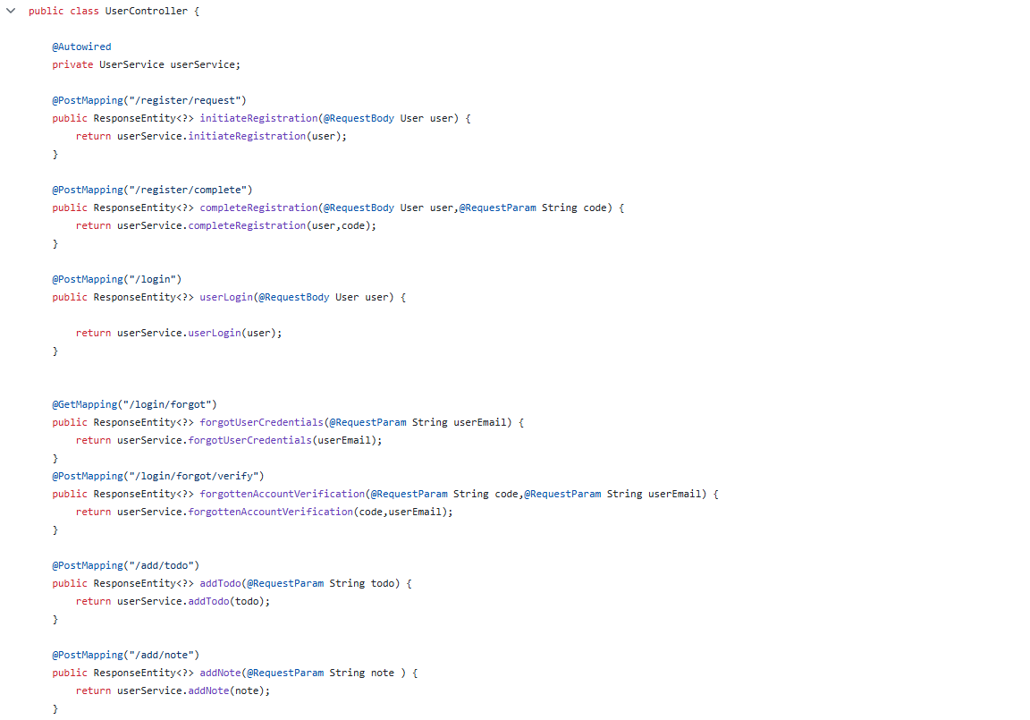

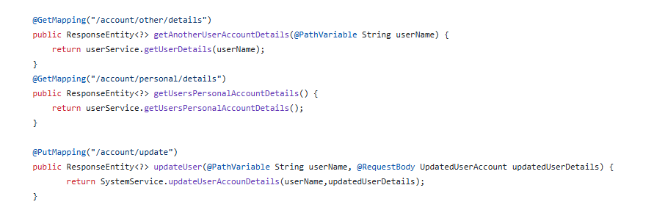

**Team**

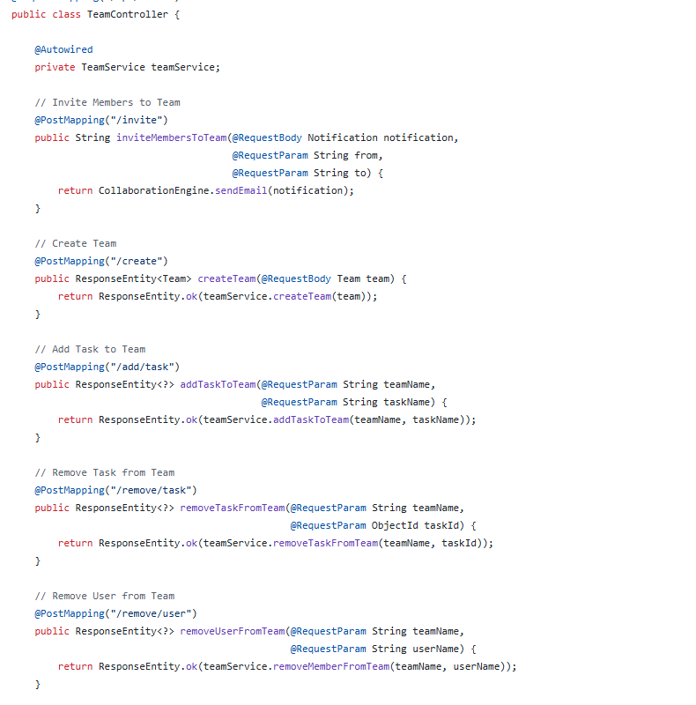

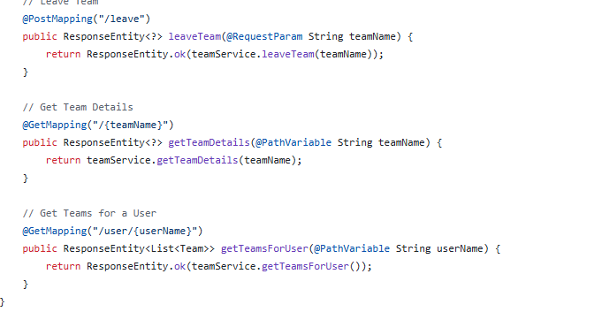

**Task**

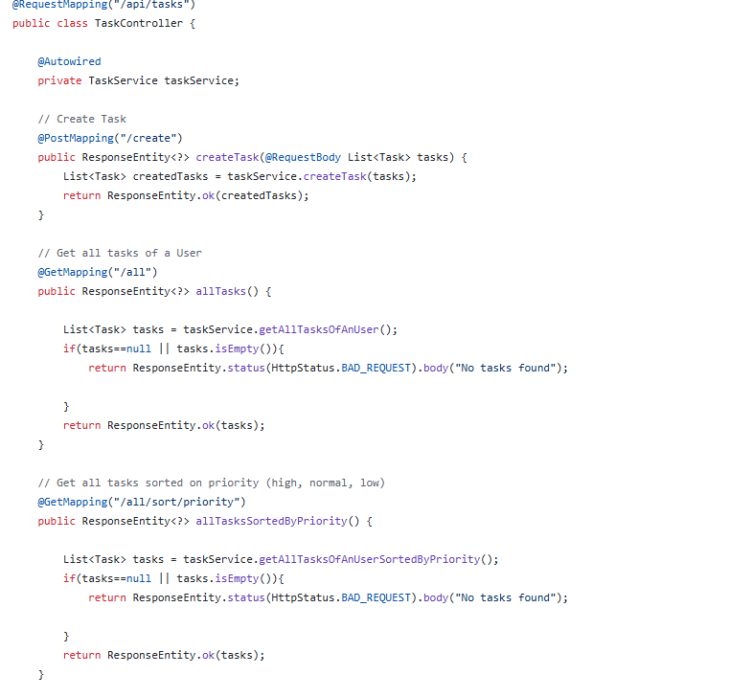

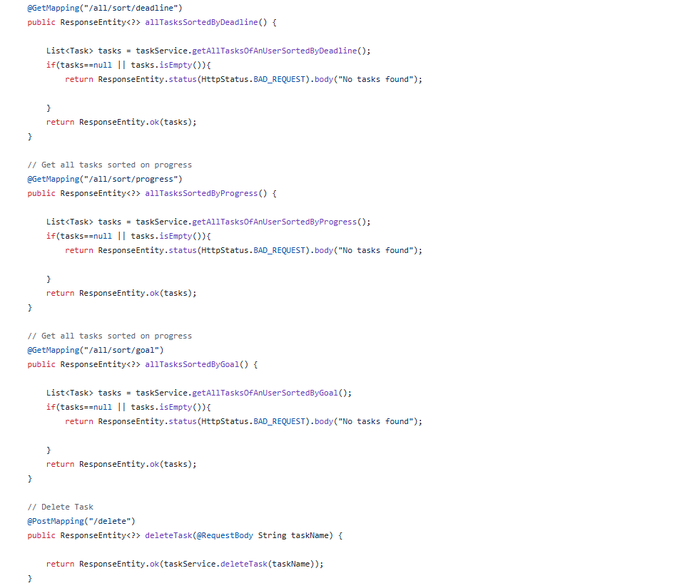

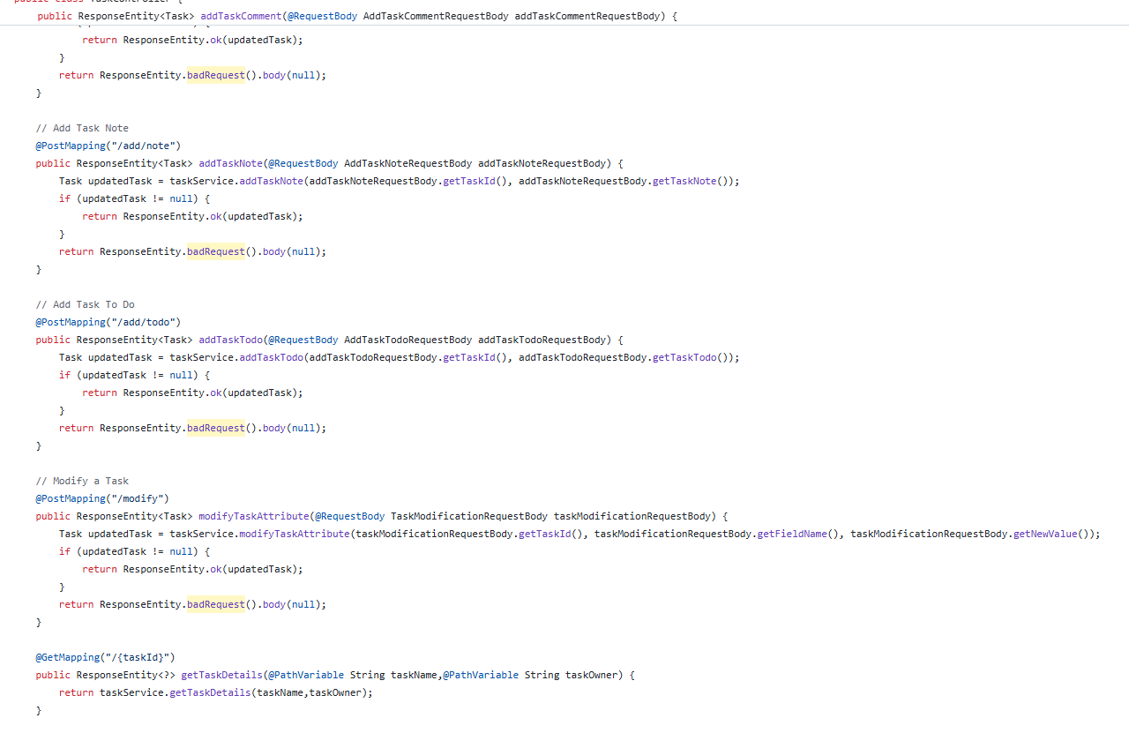

**Some Screenshots of Postman while developing Backend:**

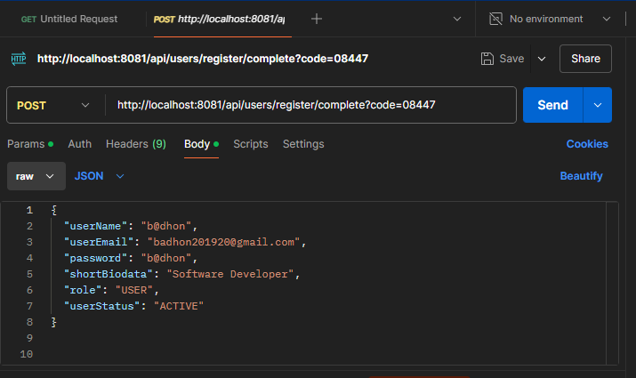

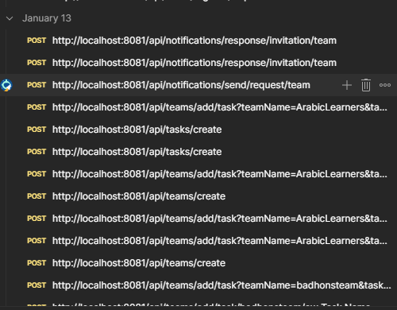

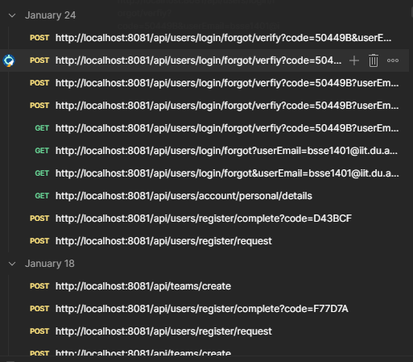

**Some Mail sent To the user :**

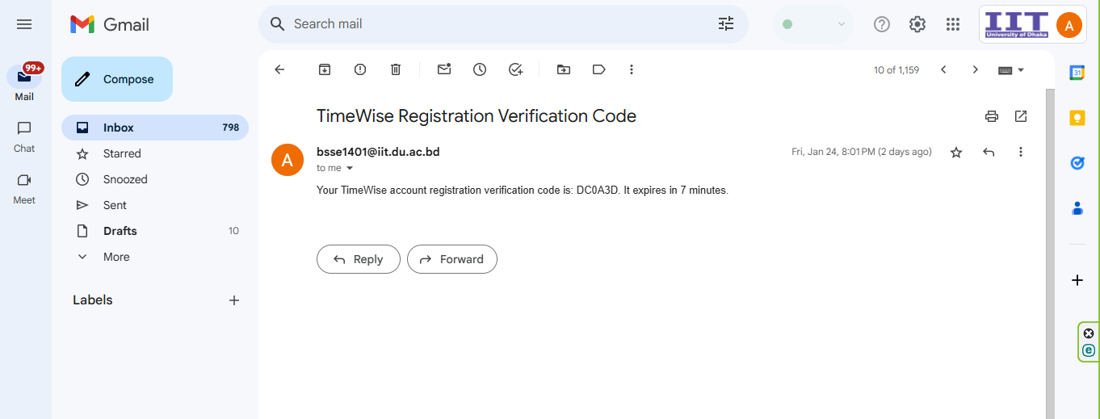

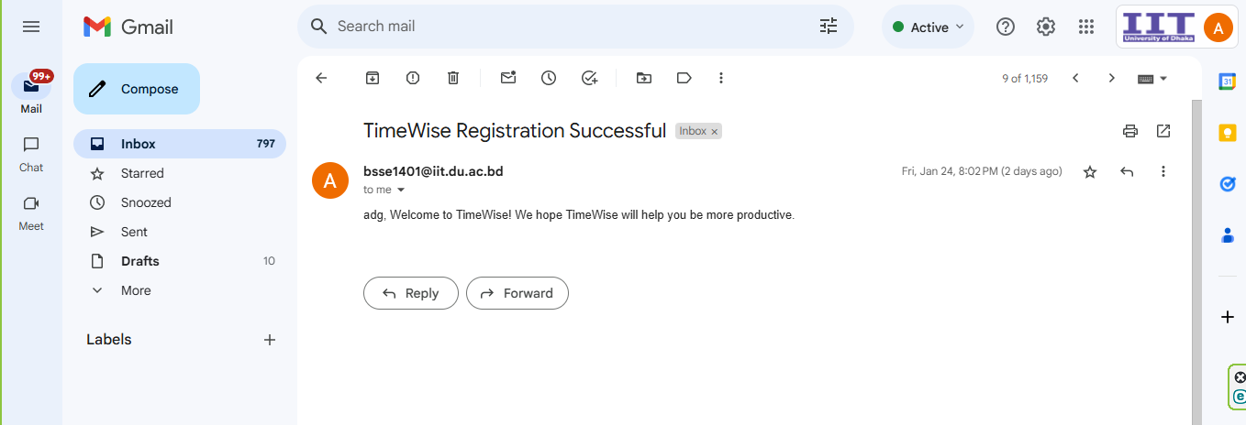

**Code Folder Structure:**

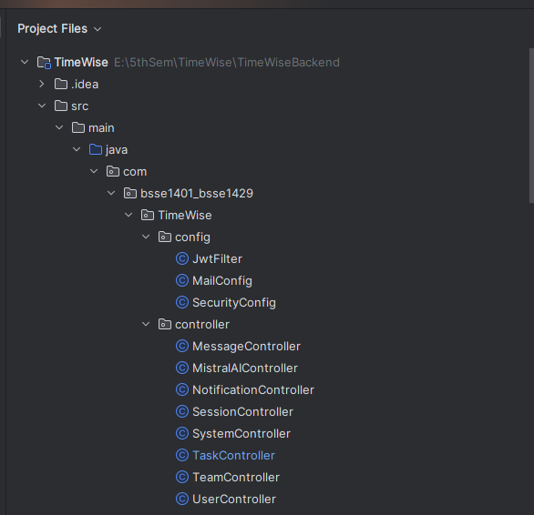

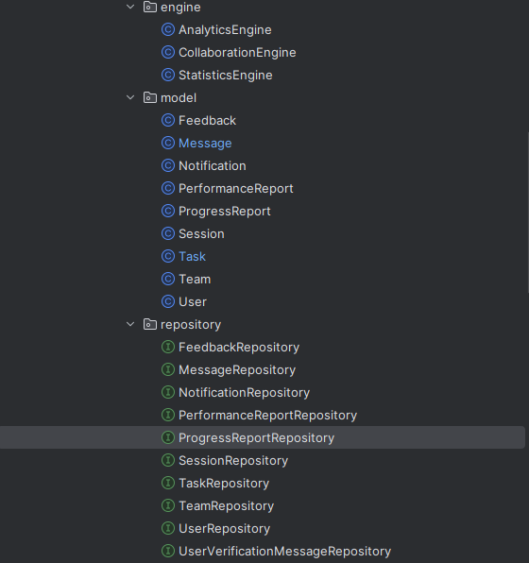

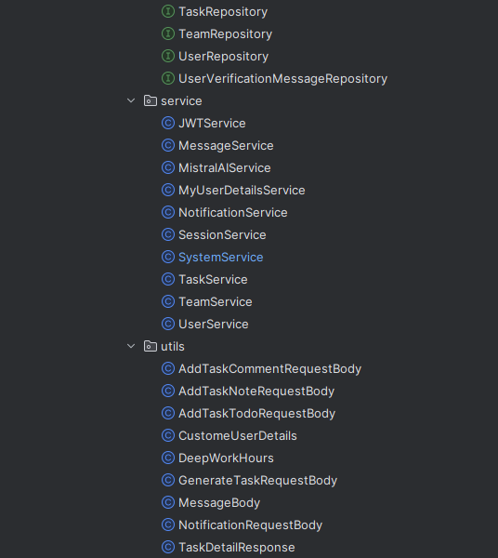

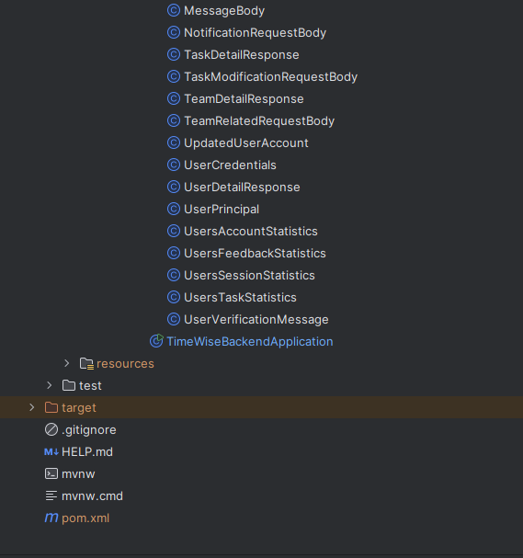

**Frontend FOlder Structuer:**

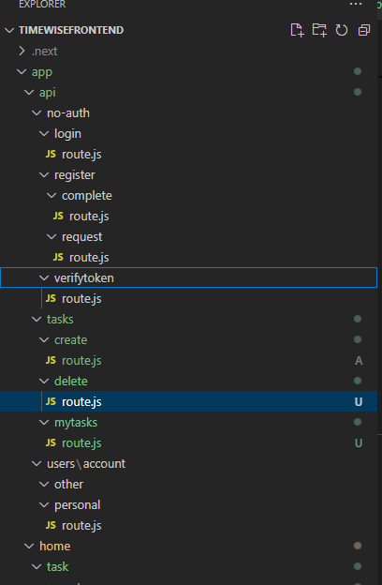

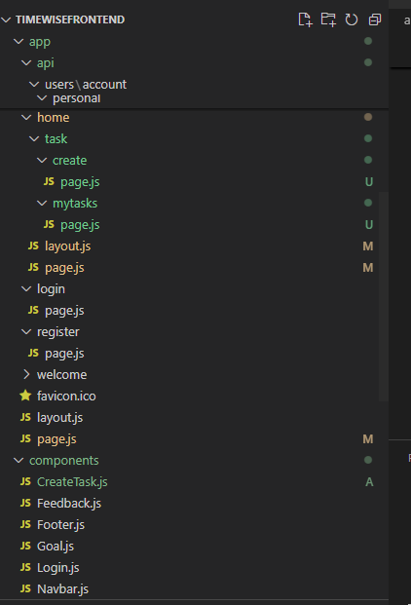

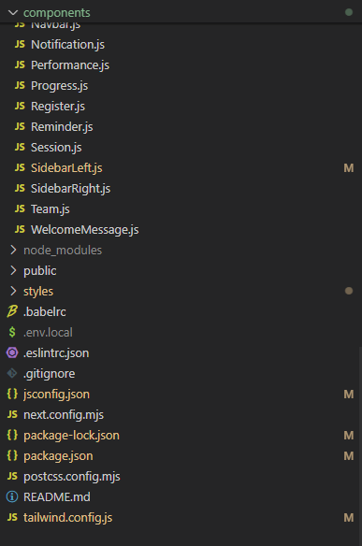

**Database:**

